**Literacy Profile**

Spring 2015

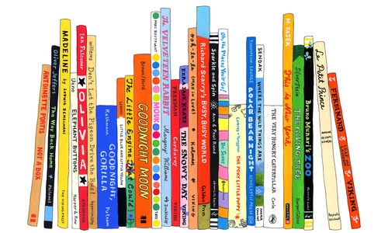

Mary Lacen Kinkel

READ 670 Practicum

CMS

Dr. Angelica Blanchette

Literacy Profile  
Mary Lacen Kinkel

Spring 2015  
READ 670

**Section II. Contextual Framework**

http://www.cucps.k12.va.us/

CC, Virginia is a rural community that was founded in 1749, known for the “1st Call for Independence”. According to the United States Census Bureau 2013 QuickFacts estimates, The population consist of 9,841 people, and is made up of 64.6% Caucasian and 32.3% African American. Primarily, families are working class and are often employed outside of the county. However, 16.3% of the population is below the poverty level, greatly impacting the number of free or reduced lunches within the county. CC Public Schools are in the 60th percentile for free and reduced lunch services, and many students receive regulation lunches. Within the county, 13% of students graduate with an associate’s degree and 58% graduate with an advanced student diploma. At the high school level, the on-time graduation rate is 94%.

CC Public Schools is the home of the Dukes, where it is their motto to be “Student Centered, Teacher Inspired”. This motto is meant to inspire all students with the confidence of accomplishing set goals, ability to contribute to their community, and acquire a strong passion for learning. There are three public schools within CC: CES (PreK-4th), CMS (5th-8th), and CHS (9th-12th). The town itself contains three local restaurants and Bear Creek State Park. The county community faces several challenges regarding internet access. There is only one high-speed internet unit for the entire county, including the schools. This reality makes if difficult for students to complete online homework and other assignments outside of school. In 2008, the schools established that each classroom receive a Promethean Board and access to computer labs and laptops. Students are also allowed to use their personal electronic devices at school for academic purposes.

For this case study, my Literacy Profile focal student is in the 6th grade at the middle school. The high school and middle school coincide within the same building, sharing resources and electives. There are currently 430 students enrolled at CMS ranging from 5th grade to 8th grade. According to the principal, the diversity make up of the school is Caucasian, African American, and Hispanic. The ESL population is low, including only Spanish speaking students. There is also a limited special need population. The middle school is currently accredited with warning and is in their second year of academic review by the state in English and mathematics. Several professionals who specialize in these areas of weakness assist the school in providing resources and strategies to support both the teachers and the students. In order to increase instructional time, the middle school implemented 85 minutes periods for the 5th and 6th grade students to build in a writing period. This schedule is meant to provide needs for students with a limited middle school staff.

My focal student’s name is, K, He is a twelve-year-old African American boy who is in the 6th grade. He has two twelve-year-old sisters and a two-year-old baby brother, who he enjoys reading to. However, an adult does not read to him to at home. During his student interview, he shared that he loves basketball, football, and playing Xbox with his friends. His favorite school subjects are mathematics and history, and he claimed to not have a least favorite subject. He loves all things comical, including SpongeBob, Disney Channel Shows, and *Diary of a Wimpy Kid*. This interview information will be highly beneficial when determining and developing instructional implications for our tutoring sessions throughout the semester.

These contextual factors and characteristics of the CC community, school, and my focal tutee student will impact instructional planning, implications, and assessments. Based on the rural nature of the county, I will take into consideration that K may have limited background knowledge, access to resources and materials, and/or high speed internet. I will need to be prepared to provide a variety of resources and materials, both electronic and paper. In addition, I find it extremely important that our tutoring sessions incorporate his likes and interests to promote motivation and engagement. Overall, I am looking forward to working with K throughout the semester and am excited to witness his literacy growth first hand.

**Section III. Assessment**

My focal student is a twelve-year-old African American boy, named K, who is in the 6th grade. K has a wonderful personality and a funny sense of humor. He thinks of himself as the class clown and loves attention from his fellow classmates and teachers. His personality and sense of humor are what drove the essential question for our sessions, “How is humor created and how do people respond?” I was able to develop a relationship with K by having meaningful conversations regarding his life and interests. He has two twelve-year-old sisters and a two-year-old baby brother, who he enjoys reading to. However, an adult does not read him to at home. During his student interview, he shared that he loves basketball, football, and playing Xbox with his friends. His favorite school subjects are mathematics and history, and he claimed to not have a least favorite subject. He loves all things comical, including SpongeBob, Disney Channel Shows, and *Diary of a Wimpy Kid*. This interview information played a significant role in determining and developing instructional implications for our tutoring sessions.

Within the middle school, the teachers use a computer assessment program called iReady to assess students. The information provided by the school regarding my tutee’s reading level, based on iReady scores, indicated that he is functioning on a 3rd grade reading level. This information led me to believe that he struggled with reading. After conducting my assessments, I found that he is truly functioning on a 5th grade reading level. However, K does not possess high motivation or interest in regards to reading in school. When he was asked to describe himself as a reader, he said, “I sometimes like to read, but I only read at an average speed.” Many of these students find it important to read as fast as possible, so he does not like the rate in which he reads. I selected K as my tutee because I wanted him to foster a love for and interest in reading. I knew that if I selected texts that he found to be interesting, and that were on his instructional level, his desire to read would most likely increase.

**Pupil Interview**

* “Get to know you” assessment
* Conversational
* Literacy development in regards to listening and speaking

**Affective Assessments**

* Reading Attitude Survey (Garfield assessment)
* The Reader Self-Perception Scale assessment
* Literacy development in regards to reading and listening

**Qualitative Reading Inventory (QRI-5)**

* Automaticity in word knowledge in isolation (WRI-Timed)
* Decoding in isolation (WRI-Untimed)
* Oral reading accuracy in context through passage reading (WRC)
* Oral reading to assess reading rate/fluency (Oral and Silent WPM)
* Oral comprehension (Narrative and Expository Texts, Look-backs if necessary)
* Silent comprehension (Narrative Text, Look-backs if necessary)
* Listening comprehension (Expository Text, Look-backs if necessary)
* Literacy development in regards to reading, listening, and speaking

**Spelling Inventory (WTW ESI Inventory)**

* Stage placement
* Feature knowledge
* Examples of using but confusing
* Literacy development in regards to listening and writing

**Writing Sample**

Assessment of...

* Planning and prewriting
* Ideas, organization, voice, sentence fluency, word choice, and conventions: spelling, punctuation, and capitalization
* Editing and correcting (Read aloud)
* Literacy development in regards to writing

**Section IV. Summary of Data Analysis and Reading Levels**

In general, K is functioning on a 4th or 5th grade reading level. This reading level places him approximately one year behind his grade level peers. The information provided by the school regarding K’s reading level, based on iReady scores, indicated that he is functioning on a 3rd grade reading level. K displays weaknesses with comprehension and summarizing. He struggles with comprehending written materials independently past the 3rd grade. However, K displays strengths in automatic word recognition, decoding, predicting and retelling. His fluency is also not a concern based on his oral reading rate.

After analyzing the assessment data, I determined that K is truly functioning on a 4th or 5th grade reading level. These reading levels were determined based on K’s Word Per Minute (WPM)/Oral Reading Rate scores. However, since his Word Recognition in Context (WRC) score is 97% and his WPM score indicates that he is only 20 words behind at the 4th grade level, I called his instructional level at 5th grade. K displays weaknesses with comprehension and summarizing. Past the 3rd grade, he struggles comprehending texts independently. When given the opportunity to utilize look-backs, K scored a 100% through the 6th grade. He struggled more with comprehending implicit information rather than explicit information. He also struggles with summarizing key information from a text without retelling the entire story. However, K displays several literacy strengths. K displays strengths in word recognition according to his Word List WRI scores. His automaticity in word knowledge and decoding in isolation are mostly independent until he hit frustration at the Upper Middle School list. Also, he is able to make predictions regarding a text through making connections and activating his prior knowledge. Lastly, K is excellent at retelling stories. He was able retell at least 50% of each passage in great detail.

K’s functional levels and motivation influence his relative successes and challenges from day-to-day in the classroom. Since he is functioning one year behind his grade level peers, this causes him to struggle. In addition, K’s attempt in trying to read as fast as possible, directly affects his ability to comprehend what he has just read. He then focuses so much on retelling in as much detail as possible that he looses sight of the main idea(s) of the text. This in return affects his ability to summarize important information. K is much more focused and motivated to read when the text is interesting to him. Otherwise, he lacks high motivation and interest to engage in reading.

**ARTIFACTS**

**Section 4.1- Student Interest Inventory**

My tutee student is a twelve-year-old African American boy, named K, who is in the 6th grade. He recently turned twelve on February 23rd. He has two twelve-year-old sisters and a two-year-old baby brother, who he enjoys reading to. However, an adult does not read him to at home. During the interview, he shared that he loves basketball, football, and playing Xbox with his friends. His favorite school subjects are mathematics and history, and he claimed to not have a least favorite subject. He loves all things comical, including SpongeBob, Disney Channel Shows, and *Diary of a Wimpy Kid*. When he was asked to describe himself as a reader, he said, “I sometimes like to read, but I only read at an average speed.” K finds it important to read as fast as possible, so he does not like the rate in which he reads. He also believes that in order to be a good reader you need to know all of the words. When asked what he does when he has trouble reading a word, he said, “I sound it out, look it up in a dictionary, or ask a teacher or a friend.”

**Section 4.2- Individual Reading Inventory**

The Qualitative Reading Inventory-5 Word List, commonly known as the QRI, was given in order to help determine a starting point for K to begin oral reading passages. This word list task is also referred to as the Word Recognition in Isolation (WRI). This assessment is conducted using flashed or timed and untimed versions, in order to find an independent, instructional, and frustration level. The timed version assesses the student’s automaticity in word knowledge in isolation. If the student is unable to recognize the word when it is flashed, he or she are given the opportunity to view the word in the untimed version. The untimed version assesses the students’ decoding abilities in isolation. K started by reading the word list Preprimer 1. This list provided high motivation for K since he was able to read every word automatically, with 100% accuracy timed. K continued to read each subsequent list until his percentage became 50% or below on the flashed or timed WRI. K displayed independent timed scores of 90 or above until the 6th grade, with the exception of 3rd grade. At the 3rd grade level, K scored an 80% timed and a 95% untimed. This score of 80% indicated instructional at 3rd grade. Through using this score at the 3rd grade level, I was able to determine where to begin passage reading (WRC) with K. After the 3rd grade, K continued to score 90% timed for 4th and 5th grade. He hit his frustration level at the Upper Middle School list, scoring a 50% timed and 75% untimed.

The Qualitative Reading Inventory-5 passage reading, commonly known as the QRI, was given in order to determine K’s independent, instructional, and frustrational reading levels. This task is referred to as the Word Recognition in Context (WRC). This assessment is conducted by starting with oral reading, using a narrative passage at the lowest instructional WRI level. At the 3rd grade level, K scored an independent percentage of 99%, an oral WPM score of 136, and an oral comprehension score of 100%. After the 3rd grade narrative passage, K’s oral WPM score began to significantly decrease. At the 4th grade level, K scored an instructional percentage of 97%, an oral WPM score of 100, and an oral comprehension score of 75%, which increased to 100% with look-backs. At the 5th grade level, K scored an instructional percentage of 97%, an oral WPM score of 89, and an oral comprehension score of 86%, which increased to 100% with look-backs. At the 6th grade level, K reached frustration, due to his oral WPM score. He scored an instructional percentage of 97%, an oral WPM score of 81, and an oral comprehension score od 86%, which increased to 100% with look-backs. His reading levels: 3rd grade independent, 4th and 5th grade instructional, and 6th grade frustrational. Since K’s Word Recognition in Context (WRC) score is 97% and his WPM score indicates that he is only 20 words behind at the 4th grade level, I called his instructional level at 5th grade.

Due to a lack of time, I was unable to complete certain assessments with K. I was unable to assess his oral reading on an expository passage at his highest instructional level, silent reading using a narrative text at the 5th grade level, and listening comprehension using an expository text on the 6th grade level based on his current grade level placement in school. If I would have been allowed more time, I would have liked to assess K with a 5th grade expository passage to further support the call I made regarding his instructional reading level.

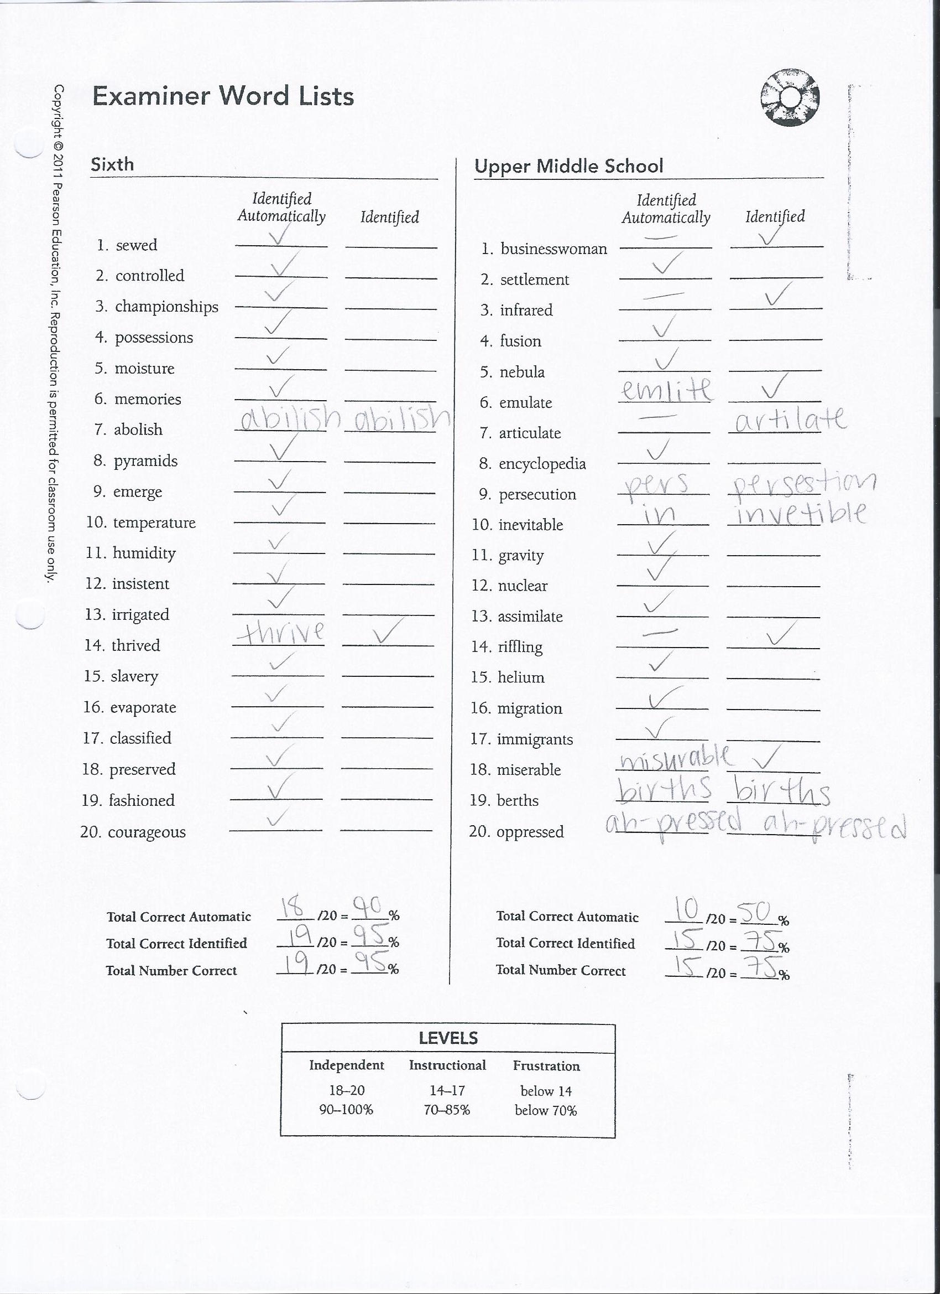

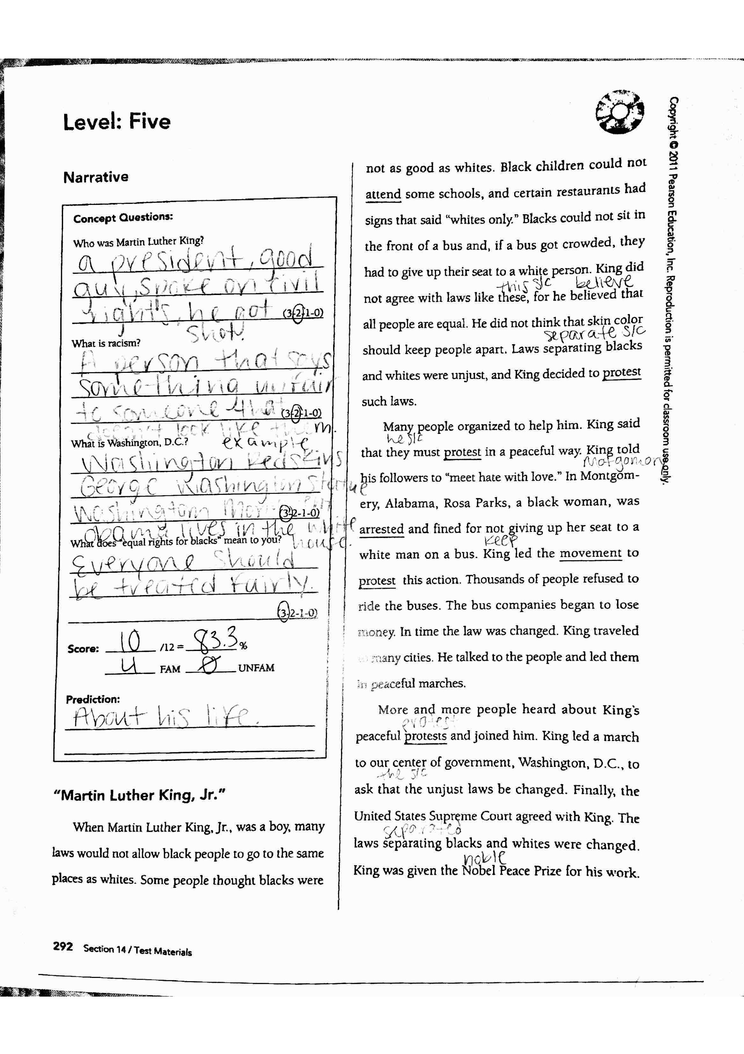

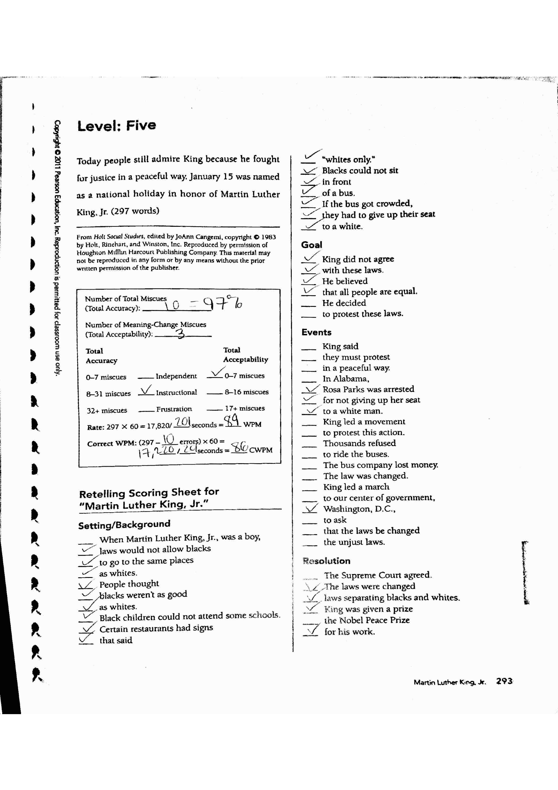

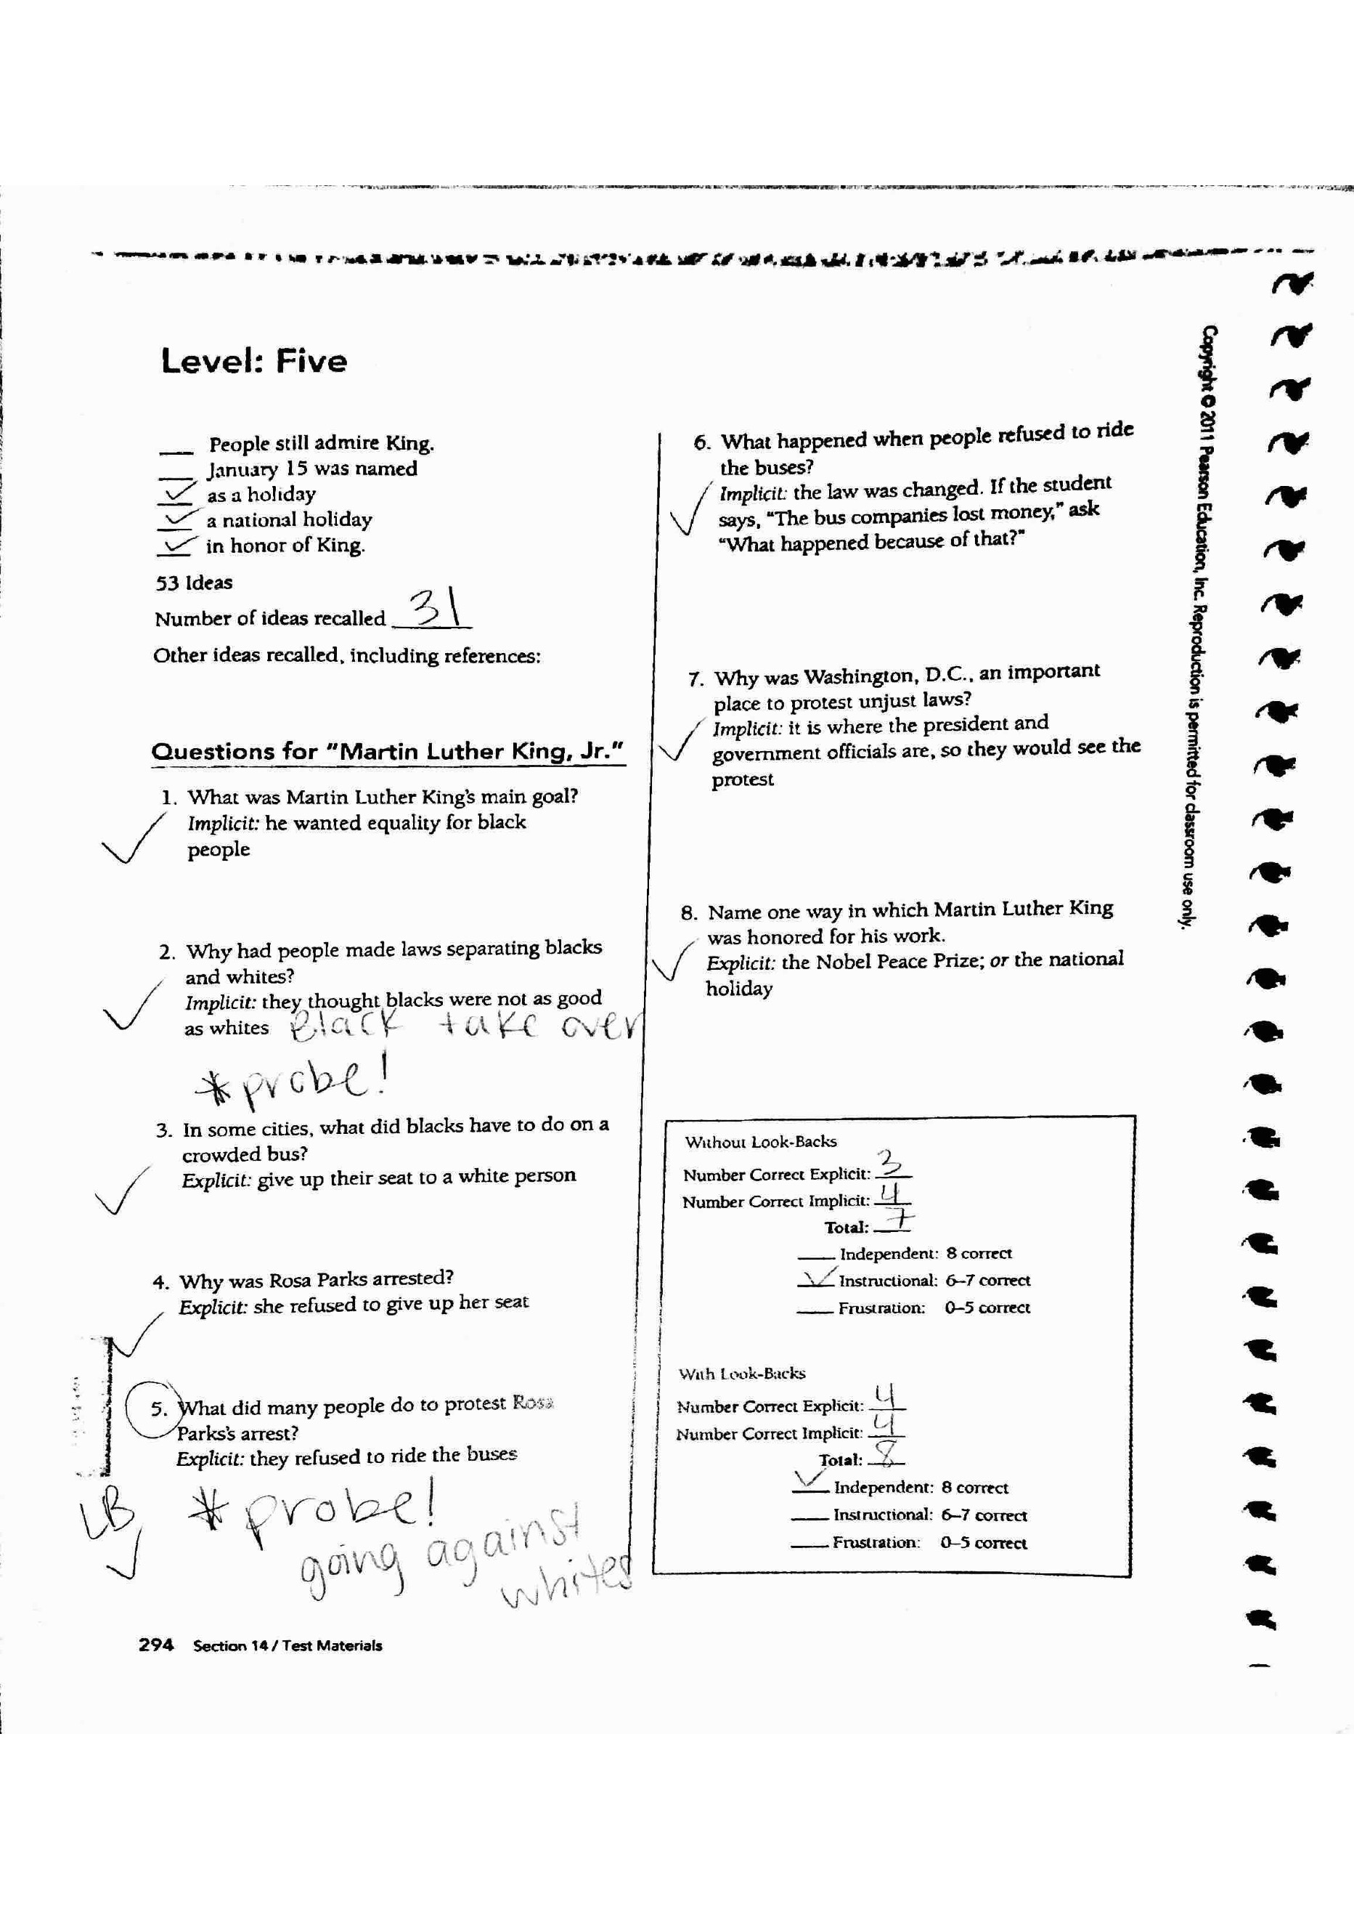

**Section 4.3- Qualitative Spelling Assessment**

The Elementary Spelling Inventory was given to determine K’s stage placement, feature knowledge, and examples of using but confusing. This particular inventory covers 1st grade through 6th grade. The results from the *Words Their Way* Elementary Spelling Inventory Feature Guide indicate that K is in the late Syllables and Affixes stage, with a score of 17/25, which equal a 68%. He displays mastery in the following features: consonants beginning and final, short vowels, diagraphs, blend, common long vowels, other vowels, inflected endings, and syllable junctures. He uses but confuses unaccented final syllables in words such as ripen and cellar. For example, he wrote “rypin” and “seller”. He also used but confuses harder suffixes like in the word civilize. For this word, he wrote “sivilise”. I chose to being instruction focusing on unaccented final syllables.

K’s initial sort will focus on –er, -ar, and –or (comparatives, agents, and things). I would recommend a modest instructional pace for K. I anticipate that he will achieve the end-of-year expectation for 6th grade. Within my lesson plans, K uses a word hunt chart to connect his knowledge of –er, -ar, and –or to pull out words from the texts that he is reading. After reading, K hunts for words that follow the -er, -ar, and -or spelling features. When words are found, he records the words in the word hunt chart. This activity allows K to make connections between his spelling and his vocabulary, while engaging with the text.

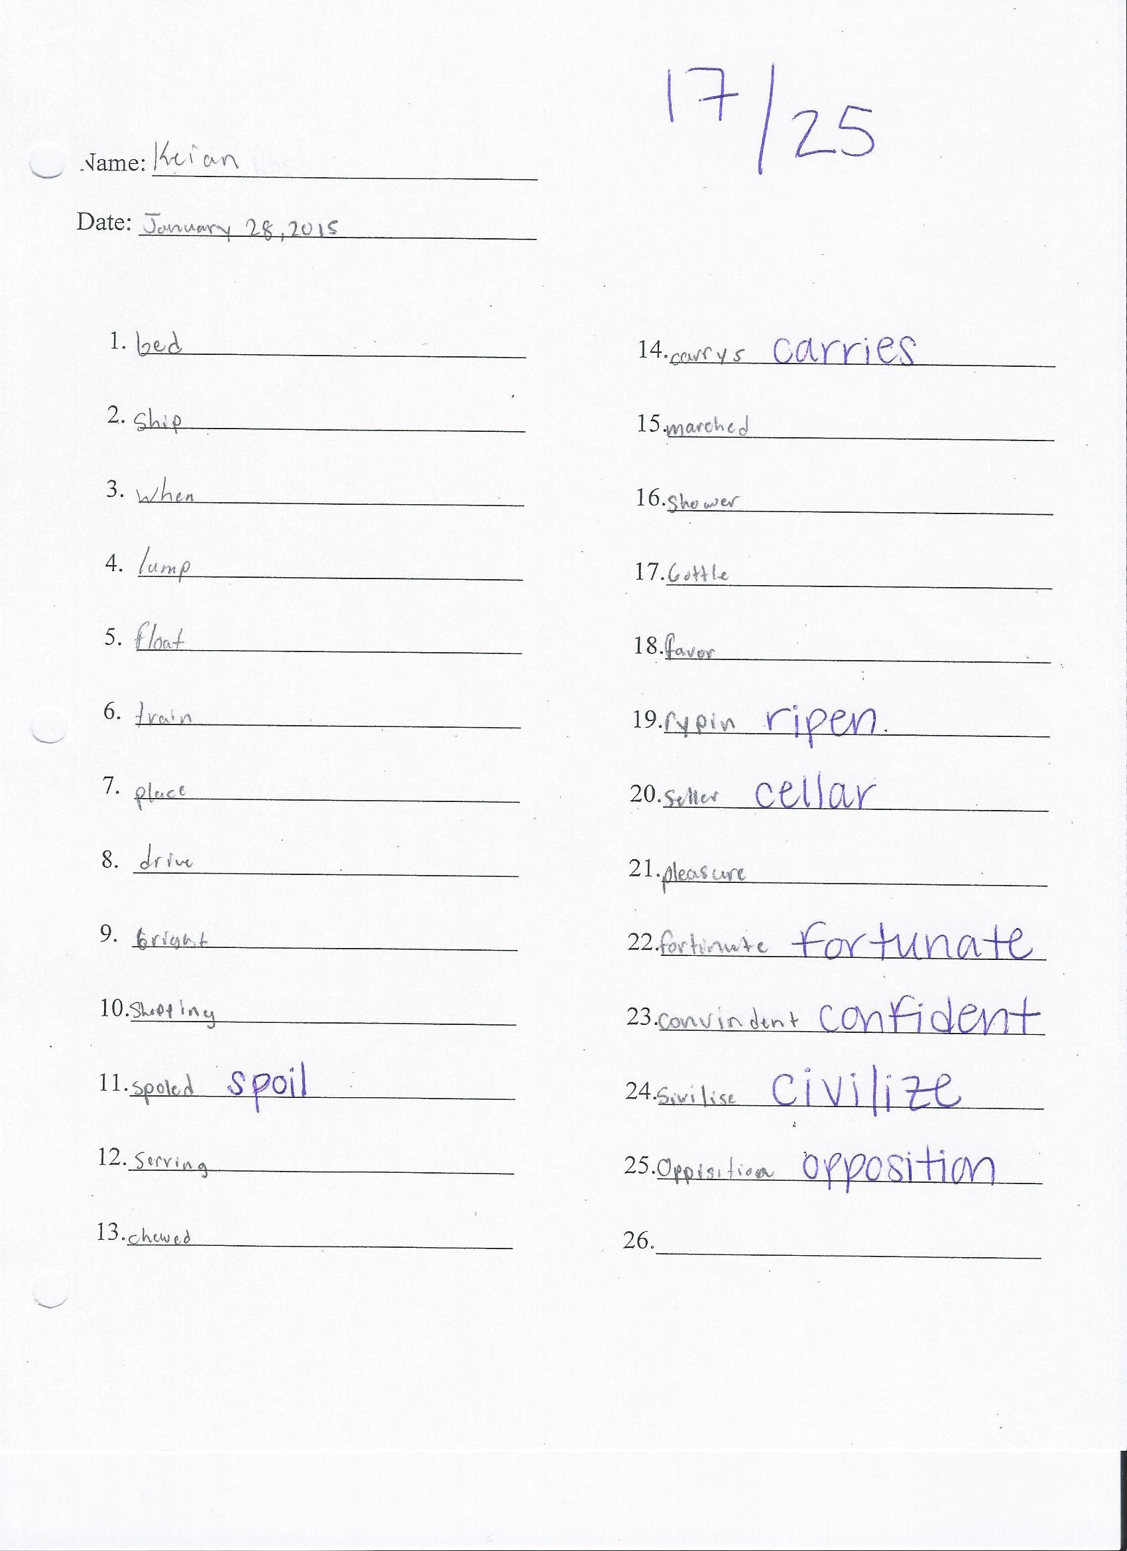

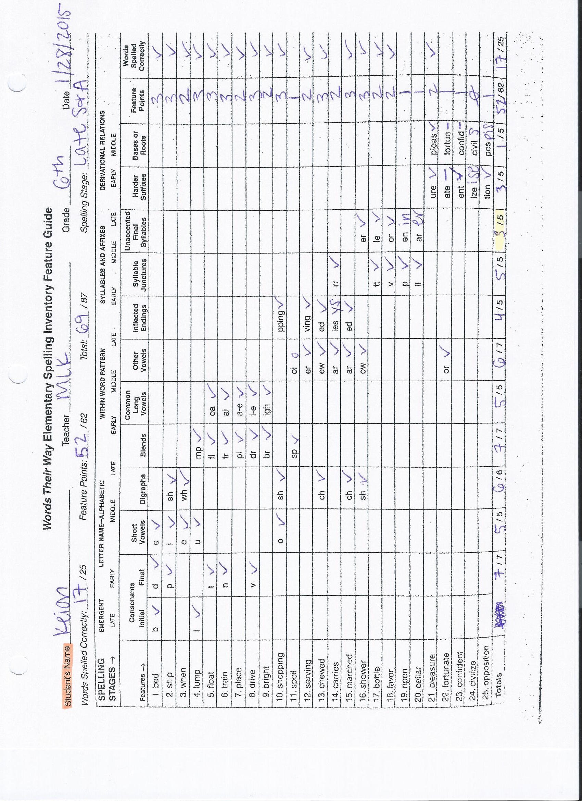

**Section 4.4- Written Language**

Due to a lack of time, I was unable to collect a complete writing sample to evaluate from K. However, based on the writing I have seen so far, I have been able to determine his areas of strengths and weaknesses. K has an excellent sense of voice within his writing through the use of the words that he chooses. Many of my lessons have been heavily focused on conventions. K shows weakness in spelling, punctuation, and capitalization. I am also hoping to increase his summarization and organization skills. K tends to sometimes struggle with ideas, which I believe is connected to his lack of motivation to want to write. It is also extremely clear that K is unsure of how to edit his own writing.

**Section 4.5- Student Interests and Affective Measures**

After taking the Elementary Reading Garfield Attitude Survey, many of K’s responses were slightly smiling Garfield (3) or mildly upset Garfield (2). From analyzing this survey, it is clear that he does not really enjoy reading in school or for school assignments. His most excited responses steamed from reading for fun or at home. According to his pupil interview, K enjoys reading to his two-year-old baby brother, but adults do not read to him at home. In addition, The Reader Self-Perception Scale indicated that the only statement he disagreed with was, “I read more than other kids.” It is obvious that K does not possess high motivation or interest in regards to reading in school. I strongly believe that if texts are selected based on his interests and his instructional level, K’s love for and interest in reading will increase.

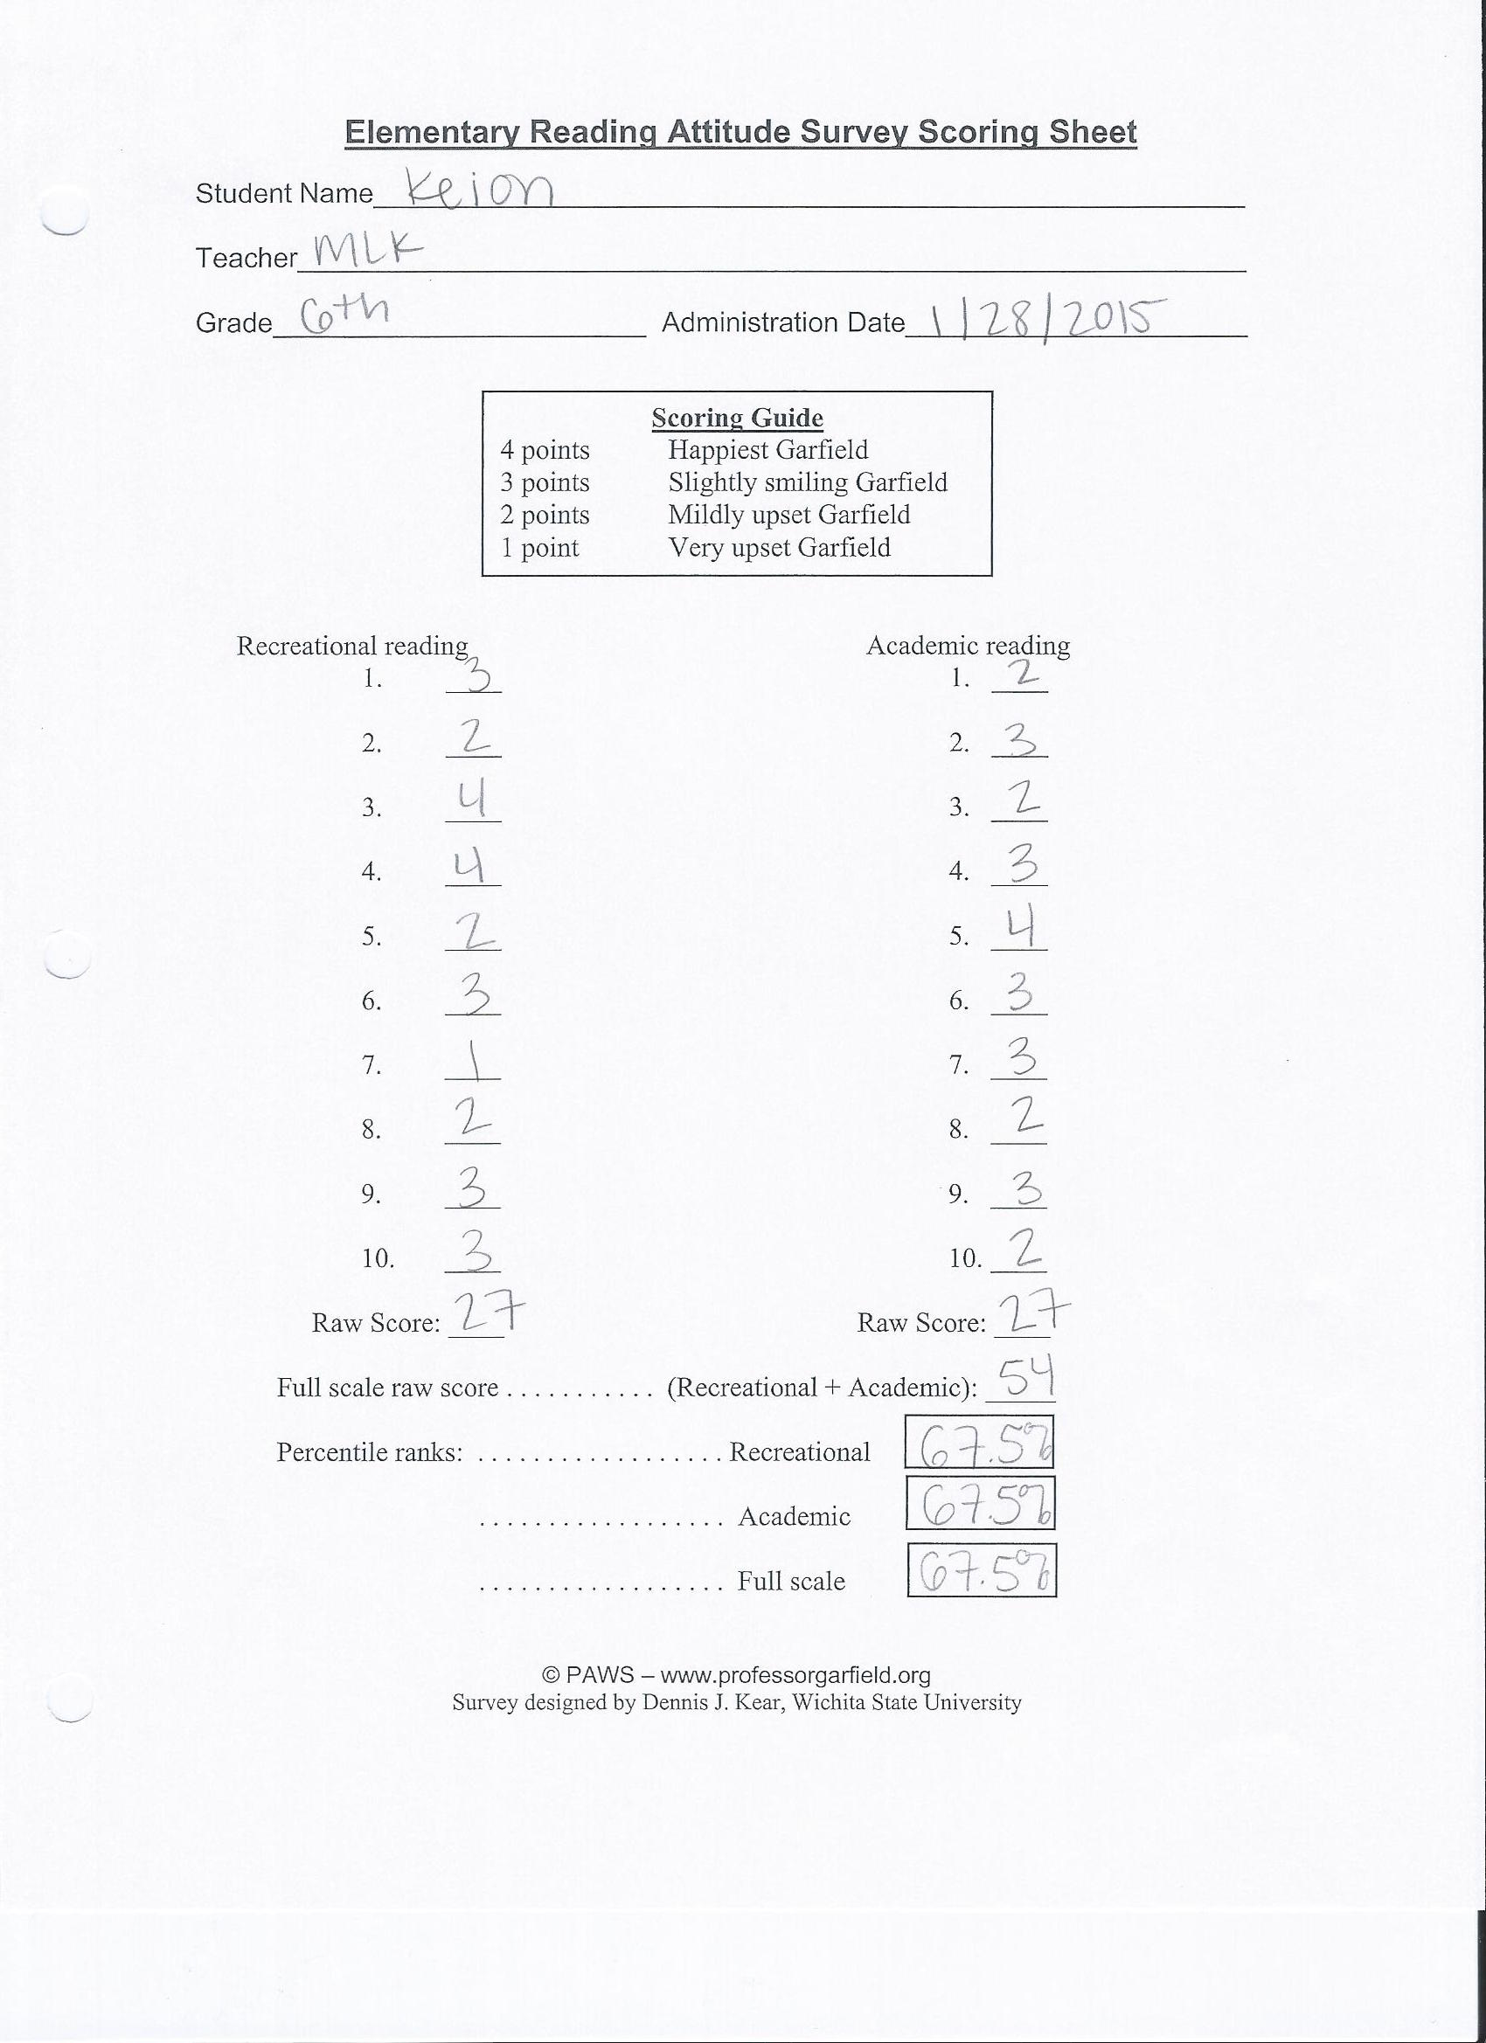

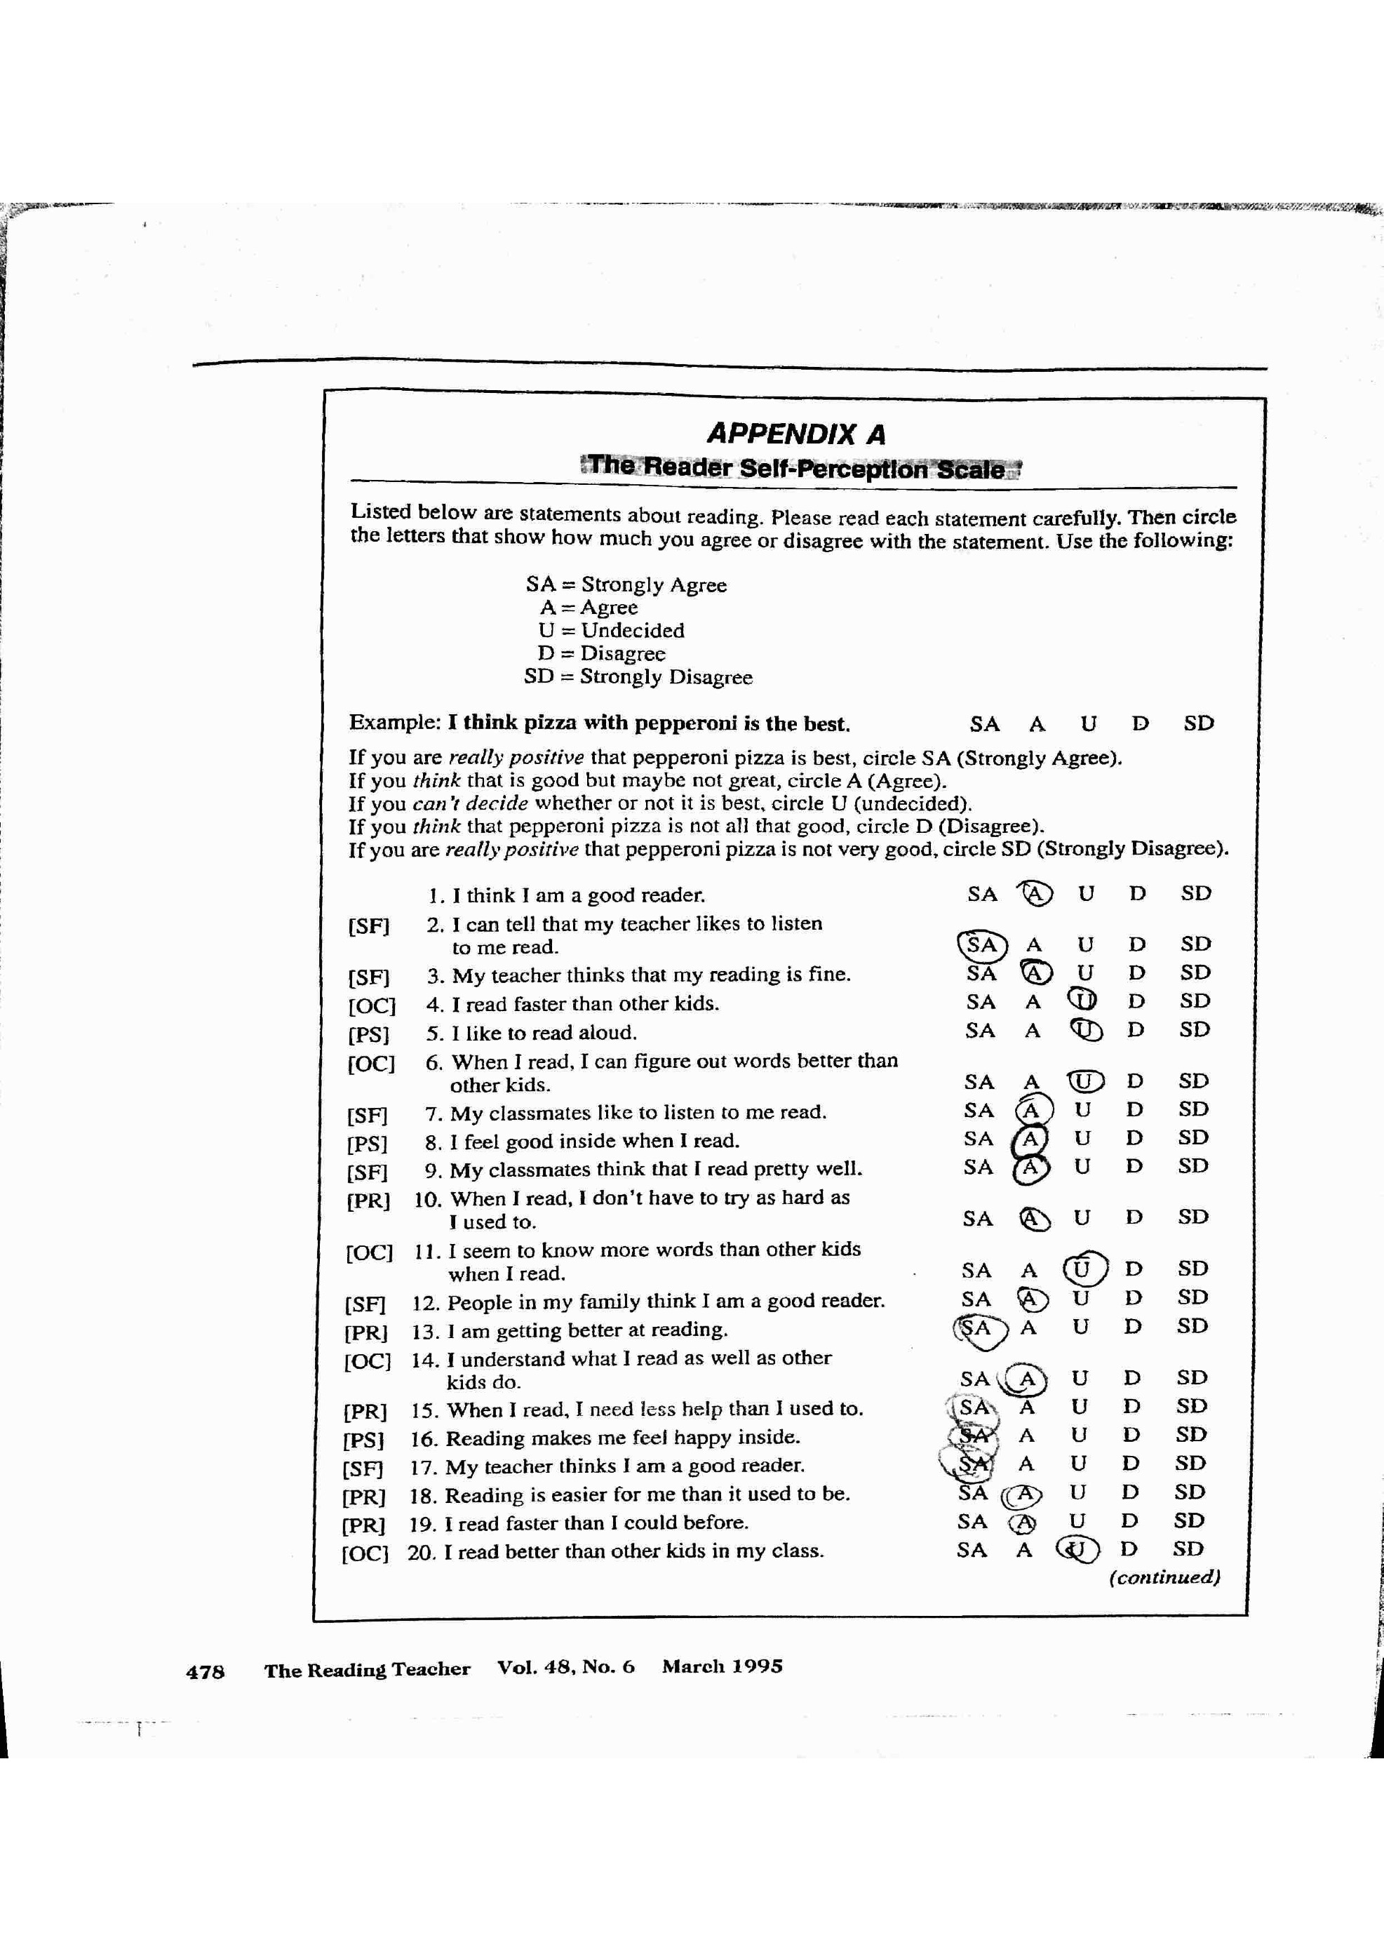

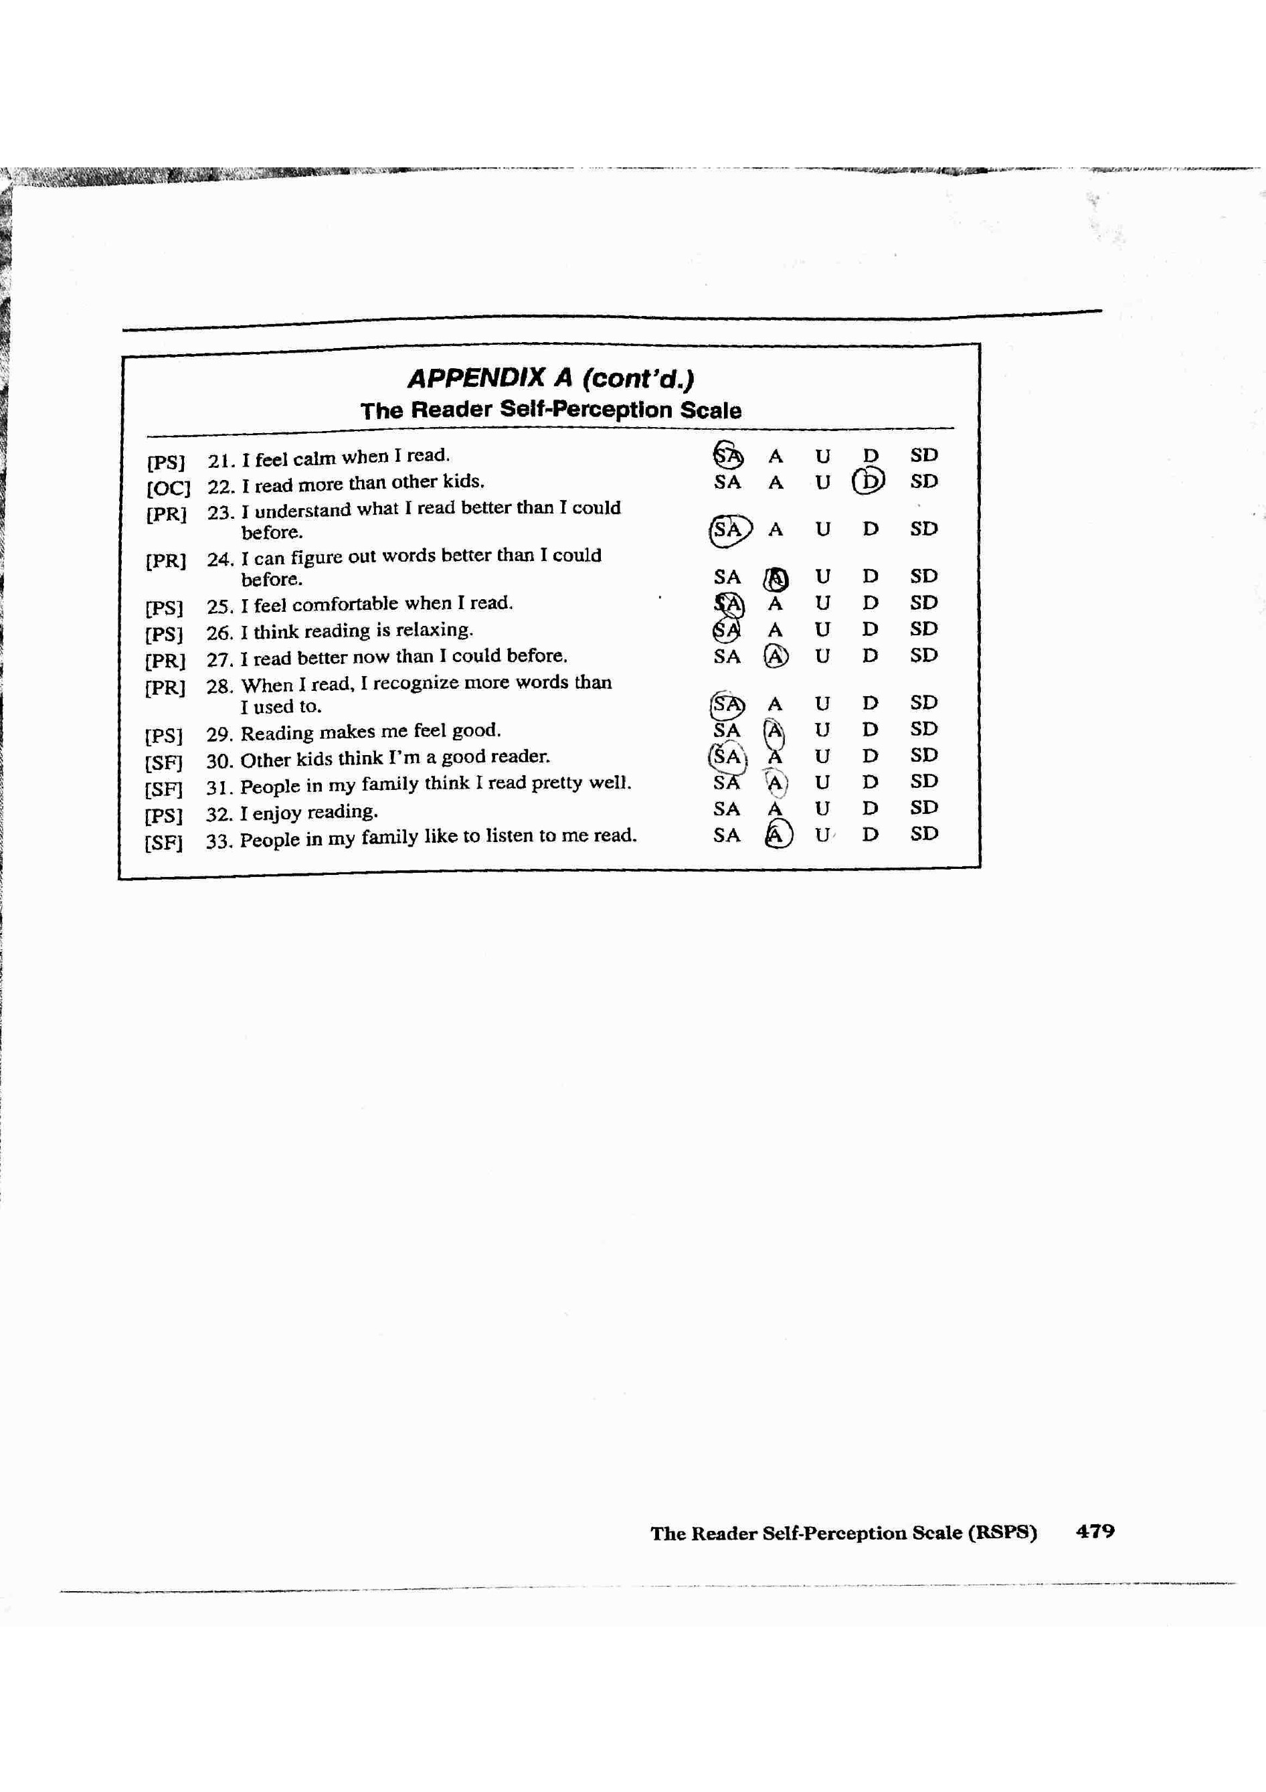

**Section 4.6- Others**

CASE SUMMARY SHEET

|  |  |  |  |  |  |  |  |  |  |
| --- | --- | --- | --- | --- | --- | --- | --- | --- | --- |
| **Word Lists (WRI)** | | | Passage Reading (WRC) | | **Reading Rate (FLUENCY)** | | **Comprehension** | | |
| **Difficulty Level**  **🡫** | **Timed**  **Timed**  **%age** | **Untimed**  **Total**  **%age** |  | **WRC**  **(% read correctly)** | **ORAL WPM** | **SILENT WPM** | **% questions answered correctly** | | |
| **ORAL** | **SILENT** | **LISTENING** |
| Preprimer 1 | **100** | **100** | Preprimer |  |  |  |  |  |  |
| **Preprimer 2/3** | **95** | **100** | **Preprimer 2/3** |  |  |  |  |  |  |
| **Primer** | **100** | **100** | **Primer** |  |  |  |  |  |  |
| **1st** | **100** | **100** | **1st** |  |  |  |  |  |  |
| **2nd** | **100** | **100** | **2nd** |  |  |  |  |  |  |
| **3rd** | **80** | **95** | **3rd** | **99 N** | **136** |  | **100** |  |  |
| **4th** | **90** | **100** | **4th** | **97 N** | **100** |  | **75/LB:100** |  |  |
| **5th** | **90** | **100** | **5th** | **97 N** | **89** |  | **86/LB:100** |  |  |
| **6th** | **90** | **95** | **6th** | **96 N** | **81** |  | **86/LB:100** |  |  |
| **UM** | **50** | **75** | **UM** |  |  |  |  |  |  |
| **HS** |  |  | **HS** |  |  |  |  |  |  |

|  |  |  |  |  |
| --- | --- | --- | --- | --- |
| **Spelling** | **Writing** | | **Affective Measures** | **Comments** |
| **WTW Inventory:** ESI  **Score:** 17/25= 68%  **Stage Placement:**  Late Syllables and Affixes  **Examples of Confusions:**  Unaccented final syllables:  (examples- ripen, cellar)  Student- rypin and seller  Harder suffixes: (example- civilize) Student- sivilise | **Strengths** | **Weaknesses** | Affect for Reading:   |  |  |  | | --- | --- | --- | |  | Raw | %ile | | Academic | 27 | 67.5 | | Recreation | 27 | 67.5 | | Total | 54 | 67.5 |  * **Many responses were slightly smiling Garfield (3) or mildly upset Garfield (2).** * **He does not really enjoy reading in school or for school assignments.** * **His most excited responses steamed from reading for fun or at home.** |  |
|  |  |
| **INDEPENDENT LEVEL: 3rd**  **INSTRUCTIONAL LEVEL: 4th/5th**  **FRUSTRATIONAL LEVEL: 6th**  Other Assessments and/or Anecdotal Notes:  Due to K’s WPM scores, I believe he is functioning on a 4th/5th grade level. However, since his WRC score is 97% and his WPM score indicates that he is only 20 words behind at the 4th grade level, I am going to call his instructional level at 5th grade. If time allows, I would like to assess K with a 5th grade expository passage.  Interview/Other Information   * Sports: basketball and football * Loves to play xbox games with his friends * TV Shows: Spongebob and Disney Channel Shows * Favorite subject(s): math and history * Does not have a least favorite subject(s) * Describe yourself as a reader… “I sometimes like to read. I read at an average speed.” * What makes someone a good reader? “If they know all of the words.” * Favorite book(s): Diary of a Wimpy Kid * Genres: mystery, humor, scary, and fiction * He has two sisters who are both twelve years old and are in the 7th grade. * He has a baby brother who is two years old, who he enjoys reading to. * He is not read to at home. | | | | |

## Instructional Goals:

|  |  |  |  |
| --- | --- | --- | --- |
| **Word Knowledge** | **Fluency** | **Comprehension & Vocabulary** | **Writing** |
| **Mastery of unaccented final syllables and harder suffixes, and begin developing his knowledge of bases and roots.**  **Sorts:**  **Unaccented final syllables:**  **–er, -ar, and –or**  **-er, -ar, and –or (comparatives, agents, and things)**  **-en, -on, -in, -ain**  **Activities:**   * **Word sorts** * **Writing sorts** * **Blind sorts** * **Speed sorts** * **Word hunts** * **Phonics games targeting S&A/DR features** | **Improve word recognition, in context and in isolation.**  **K will work on improving automatic word recognition at the 3rd grade level, because his instructional level is 4th/5th grade.**  **His untimed WRI scores at Upper Middle needs definite improvement.**  **Activities:**   * **Concentration** * **Use a word bank/ring/wall for systematic instruction with high frequency words** * **Build high frequency words with letter tiles**   **Target: To improve accuracy, speed, and prosody.**  **Improve phrasing and expression while reading.**  **Activities:**   * **Model fluent reading through read-alouds, to improve prosody** * **Wide reading across text structures and genres** * **Use poetry, songs, or speeches to develop phrasing and expression.** * **Reader’s Theater** * **Partner reading** | **Improve use of comprehension strategies before, during, and after reading.**  **Comprehension Activities:**   * **DR-TA’s** * **Different text structures** * **Introduce and model, then guided/independent practice of comprehension strategies (i.e. summarizing, questioning, monitoring, and inferring)** * **Graphic organizers- word maps, Venn Diagrams, story maps, KWL charts** * **Retelling** * **Summarizing** * **Determining Importance** * **Think-Pair-Share** * **Highlighting** * **Sticky notes**   **Increase vocabulary knowledge to improve comprehension.**  **Vocabulary Activities:**   * **Concept maps** * **Word maps** * **Semantic feature analysis** * **Semantic mapping** * **List, group, label** | **Not completed!**  **Activities:**   * **Written response to readings** * **Partner writing** * **Quickwrites** * **Graphic Organizers** * **Model and practice specific strategies to improve writing** * **Self-assessment rubrics** * **Different text structures** * **Mentor texts** |

|  |  |  |  |  |  |  |  |
| --- | --- | --- | --- | --- | --- | --- | --- |
| MISCUE | TEXT | GRAPHICALLY SIMILAR  INITIAL FINAL | | ENDINGS | SEMANTICALLY ACCEPTABLE | Function WORDS | SELF-CORRECTED |
| Johnny | John | + | - | - | + | No | No |
| -- | They…use | - | - | - | - | Yes | Yes |
| Squished | Squeezed | + | - | + | + | No | No |
| Frontnear | Frontier | + | - | - | - | No | No |
| Forestes | Forests | + | + | + | + | No | No |
| Some | Out | - | - | - | + | No | No |
| The | -- | - | - | - | + | Yes | No |
| Wore | Where | + | + | - | - | Yes | No |
| COLUMN TOTAL  TOTAL MISCUES  COLUMN MISCUES %AGE | | 5  8  63 | 2  8  25 | 2  8  25 | 5  8  63 | 3  8  38 | 1  8  13 |

|  |  |  |  |  |  |  |  |
| --- | --- | --- | --- | --- | --- | --- | --- |
| MISCUE | TEXT | GRAPHICALLY SIMILAR  INITIAL FINAL | | ENDINGS | SEMANTICALLY ACCEPTABLE | Function WORDS | SELF-CORRECTED |
| This | These | + | - | - | + | Yes | Yes |
| Believe | Believed | + | - | + | + | No | No |
| Separate | Separated | + | - | + | + | No | Yes |
| He | They | - | - | - | - | Yes | Yes |
| Motgomory | Montgomery | + | + | - | + | No | No |
| Keep | King | + | - | - | - | No | No |
| Protest | Protests | + | - | + | + | No | No |
| The | That | + | - | - | - | Yes | Yes |
| Separated | Separating | + | - | + | + | No | No |
| Noble | Nobel | + | - | - | + | No | No |
| COLUMN TOTAL  TOTAL MISCUES  COLUMN MISCUES %AGE | | 9  10  90 | 1  10  10 | 4  10  40 | 7  10  70 | 3  10  30 | 4  10  40 |

**Section V. Instructional Goals**

**Word Knowledge (Phonics)**

To display mastery of unaccented final syllables and harder suffixes, and begin developing his knowledge of bases and roots

Sorts:

Unaccented final syllables:

–er, -ar, and –or

-er, -ar, and –or (comparatives, agents, and things)

-en, -on, -in, -ain

Activities:

* Word sorts
* Writing sorts
* Blind sorts
* Speed sorts
* Word hunts
* Phonics games targeting S&A/DR features

**Fluency**

To improve word recognition, in context and in isolation

To improve automatic word recognition at the 3rd grade level, because K’s instructional level is 4th/5th grade

Activities:

* Concentration
* Use a word bank/ring/wall for systematic instruction with high frequency words
* Build high frequency words with letter tiles

To improve accuracy, speed, and prosody

To improve phrasing and expression while reading

Activities:

* Model fluent reading through read-alouds, to improve prosody
* Wide reading across text structures and genres
* Use poetry, songs, or speeches to develop phrasing and expression.
* Reader’s Theater
* Partner reading

**Vocabulary**

To increase vocabulary knowledge to improve comprehension

Vocabulary Activities:

* Concept maps
* Word maps
* Semantic feature analysis
* Semantic mapping
* List, group, label

**Comprehension**

To improve use of comprehension strategies before, during, and after reading: determining importance, retelling, summarizing

Comprehension Activities:

* DR-TA’s
* Different text structures
* Introduce and model, then guided/independent practice of comprehension strategies (i.e. summarizing, questioning, monitoring, and inferring)
* Graphic organizers- word maps, Venn Diagrams, story maps, KWL charts
* Retelling
* Summarizing
* Determining Importance
* Think-Pair-Share
* Highlighting
* Stick notes

**Writing**

To improve the use of conventions such as spelling, punctuation, and capitalization

To increase summarization and organization skills

To develop ideas through the use of pre-writing strategies such as graphic organizers

Activities:

* Written response to readings
* Partner writing
* Quickwrites
* Graphic Organizers
* Model and practice specific strategies to improve writing
* Self-assessment rubrics
* Different text structures
* Mentor texts
* Sum It Up
* RAFT

**Section VI. Evidence of Research Base: Individualized Instructional Goals (Lesson Planning)**

**Word Knowledge (Phonics)**

One way to improve spelling and automaticity in word knowledge is through improving knowledge of unaccented final syllable. According to *Words Their Way* by Bear, Invernizz, and Johnston students need to pay close attention to unaccented final syllables, because it is one in which the spelling of the vowel is not clearly long or short. When completing sort with these words, “you will find there is often no tidy generalization that governs the spelling and students may have to simply commit many of these words to memory” (2012).

Word hunts are an excellent way for students to make connections between their spelling and their vocabulary, while engaging with the text. Bear, Invernizz, and Johnston explain, “In word hunts, students hunt through their reading and writing for words that are additional examples of the sounds, pattern, or meaning until they are studying” (2012).

**Fluency**

One way to improve fluency is by developing appropriate phrasing, expression, and prosody while reading. Use poetry, songs, or speeches to develop phrasing and expression. According to Gunning, “The NAEP defines fluency as the ease or “naturalness” of reading. The key elements include grouping or phrasing of words are revealed trough the intonation, stress, and pause exhibited by readers, adherence to author’s syntax, and expressiveness of oral reading, interjecting a sense of feeling, anticipation, or characterization” (2010).

Partner reading or buddy reading is an excellent way for students to practice reading fluently with appropriate phrasing, expression, and prosody. Gunning explains, “In buddy reading, two students who are on a similar level read together. They might read alternate pages or, if they are reading a script, take different parts. Or they might read silently and then discuss what they have read” (2010).

**Vocabulary**

One way to increase vocabulary knowledge to improve comprehension is through the use of semantic mapping. According to Gunning, “Semantic mapping is based on the list-group-label technique and combines brainstorming and graphically organizing information” (2010). This activity has the students place the main idea in the center and uses a series of lines and circles to show how supporting details or ideas are related to it. Gunning suggests, “For the technique to be of optimum value, students should participate in the creation of maps. If teachers create maps, they are the ones who sift the information and so students do not have the opportunity to organize and process terms.

**Comprehension**

Improving the use of comprehension strategies before, during, and after reading to determining importance, retell, or summarize can be accomplished through using a variety of activities. These activities may include Think-Pair-Share, highlighting, using sticky notes, and discussions.

One way to improve comprehension is through retelling and summarizing. Retelling is structured around the main elements of a story such as setting, characters, plot, goal, story problem, and theme. According to Gunning, “To retell a selection, the student must comprehend the story, possess the language required to retell the story, and be able to organize the events of the selection in sequence” (2010). In addition, summarizing after reading is highly important. According to Gunning, “Summarizing is the most effective comprehension strategy of all. Summarizing is a method for both improving and checking comprehension” (2010). The students must be able to select, organize, and restate the main elements in a passage, to enhance understanding and to promote recalling.

**Writing**

One way to improve writing is through to use of pre-writing strategies such as graphic organizers. These graphic organizers can be used as a brainstorming tool and can also assist students in developing organization skills. According to Gunning, “The core of prewriting is topic selection. If students are going to invest time and energy and put themselves into their writing, they must have a sense of personal involvement in their writing” (2010). These topics should be selected by the student to increase motivation and overall success. Conventions such as spelling, punctuation, and capitalization are to be taken into consideration throughout the writing process.

**VII. Instructional Plan**

**Instructional Planning Guide**

Tutor’s Name: Mary Lacen Kinkel

Student Name: K

Age: 11

Grade: 6th

Instructional Reader Type:

Independent reading level: 3rd

Instructional reading level: 4th/5th

Frustrational reading level: 6th

Notes on reading:

• He does not really enjoy reading in school or for school assignments.

• He enjoys reading for fun of at home.

• Describe yourself as a reader… “I sometimes like to read. I read at an average speed.”

• What makes someone a good reader? “If they know all of the words.”

• Favorite book(s): Diary of a Wimpy Kid

• Genres: mystery, humor, scary, and fiction

• He is not read to at home.

• He enjoys reading to his younger brother.

• Needs improvement of comprehension strategies before, during, and after reading.

• Need to increase vocabulary knowledge to improve comprehension.

*Word Study Stage:* Late Syllables and Affixes *Begin Instruction with which features:* Unaccented final syllables -er, -ar, and -or

Focus instruction on ***(select 1 main area)***:

What Essential Overarching Question will guide our lessons over the 6 weeks?

How is humor created and how do people respond?

What comprehension strategy will we work to build towards independence?

Detemining Importance

What writing genre and/or focus will we include in our studies?

Narrative/Humor

|  |  |  |  |
| --- | --- | --- | --- |
| **Lesson** | **Reading for Fluency** | **Word Knowledge** | **Reading and Writing** |
| **1** | Not a focus area for my students. | **Features:** Unaccented final syllables -er, -ar, and -or  **Activity/ies:**  Word sort  Speed sort | **Text:**  N/A  **Writing**:  N/A |
| **2** | Not a focus area for my students. | **Features:** Unaccented final syllables -er, -ar, and -or  **Activity/ies:**  Word hunt chart | **Text:**  The Diary of a Wimpy Kid by Jeff Kinney pages 1-16/Tuesday-Friday  Reading Level: 5.3  Genre: Narrative/Comedy and Humor  **Writing**:  Humorous RAFT  Objective:  After identifying and analyzing elements of humor within pages 1-16/Tuesday-Friday of Diary of a Wimpy Kid by Jeff Kinney, the students will understand why the author chose to utilize humor within the narrative text. |
| **3** | Not a focus area for my students. | **Features:** Unaccented final syllables -er, -ar, and -or  **Activity/ies:**  Word hunt chart | **Text:**  Where the Sidewalk Ends by Shel Silverstein "Sick"  Reading Level: 3.9  Genre: Poetry/Comedy and Humor  **Writing**:  Humorous RAFT (from last lesson)  Graphic Organizer  Objective:  After identifying and analyzing elements of humor within the poem "Sick" from Where the Sidewalk Ends by Shel Silverstein, the students will understand why the author chose certain words to utilize humor. |
| **4** | Not a focus area for my students. | **Features:** Unaccented final syllables -er, -ar, and -or  **Activity/ies:**  Word hunt chart | **Text:**  The Stinky Cheese Man and Other Fairly Stupid Tales by Jon Scieszka  Reading Level: 3.9  Genre: Fables/Comedy and Humor  Funny Business: Conversations with Writers of Comedy by Leonard S. Marcus  Reading Level: 5+  **Writing**:  Response Journal  Objective:  After identifying and analyzing elements of humor within the fable The Stinky Cheese Man by Jon Scieszka, the students will understand why the author chose to utilize humor.  After reading Funny Business: Conversations with Writers of Comedy by Leonard S. Marcus, the students will be able to understand the author's personality and purpose for using humor within his creations. |
| **5** | Not a focus area for my students. | **Features:** Unaccented final syllables -er, -ar, and -or  **Activity/ies:**  Word hunt chart | **Text:**  The Adventures of Captain Underpants by Dav Pilkey  Reading Level: 4.5  Genre: Narrative/Comedy and Humor  **Writing**:  Sum It Up  Objective:  After identifying and analyzing elements of humor within chapters 1-3 of The Adventures of Captain Underpants by Dav Pilkey, the students will understand why the author chose to utilize humor within the narrative text. |
| **6** | Not a focus area for my students. | **Features:** Unaccented final syllables -er, -ar, and -or  **Activity/ies:**  Word hunt chart | **Text:**  SpongeBob  Genre: Comic/Comedy and Humor  **Writing**:  Create and illustrate a Humorous Comic  Answer Essential Question  Objective:  After examining and analyzing elements of humor within the SpongeBob comic, the students will understand why the author chose certain words and pictures to utilize humor.  The students will be able to answer the essential question, "How is humor created and how do people respond?" |

**VIII. Tutoring Log**

|  |  |  |  |  |
| --- | --- | --- | --- | --- |
| **Session #** | **Date** | **Arrival & Departure** | **Total Time** | **Comments** |
| **1** | 1/28/15 | 1-3pm | 2 hours | Pre-Assessments |
| **2** | 2/4/15 | 1-3pm | 2 hours | Pre-Assessments |
| **3** | 2/11/15 | 1-3pm | 2 hours | Lesson Plan #1  Instructional Word Knowledge |
| **4** | 2/18/15 | 1-3pm | 2 hours | Cancelled: Snow Day |
| **5** | 2/25/15 | 1-3pm | 2 hours | Lesson Plan #2 Comprehensive |
| **6** | 3/11/15 | 1-3pm | 2 hours | Snow Make-Up Day: Lesson Plan #3 Comprehensive |
| **7** | 3/18/15 | 1-3pm | 2 hours | Lesson Plan #4 Comprehensive |
| **8** | 3/25/15 | 1-3pm | 2 hours | Lesson Plan #5 Comprehensive |
| **9** | 4/1/15 | 1-3pm | 2 hours | Lesson Plan #6 Comprehensive |
| **10** | 4/15/15 | 1-3pm | 2 hours | Progress-Monitoring |

**IX. Literacy Lessons & Reflections**

|  |  |  |  |  |
| --- | --- | --- | --- | --- |
| **Name:** K and B | | **Tutor: Mary Lacen Kinkel** | **Date:** 2/11/2015 | **Lesson:** #1 Word Knowlege |
| **Unit EQ:** |  | | | |
| **Objective:** | Provide a statement of what students will be able to do **AS A RESULT** of (rather than AS PART OF) this lesson. | | | |
| **Lesson Assmt:** | Describe how you will collect **evidence** that individual students have indeed met the lesson objective: | | | |
| **Fluency (10 minutes beginning; 5 minutes end)** | | | | |
| **PASSAGE:**  *(Review TRR chart from last session. Discuss rate/fluency goals.)*   * **Timed Repeated Reading (TRR)**  1. **Teacher Model**    1. Read aloud the passage to the student.    2. Model good inflection and speed (not too fast, not too slow). 2. **Silent Read**    1. The child reads the passage silently for practice, underlining difficult words. Discuss. 3. **COLD Read Aloud for Timing**    1. Time his/her reading rate.    2. Student completes the TRR chart.    3. Emphasize rate growth and error decrease.  * **Return here AT THE END OF THE LESSON**  1. **HOT Read Aloud for Timing** (same as steps a. – c. in #3) 2. **3rd HOT Read Aloud for Timing** (same as steps a. – c. in #3) | | | |  |  |  | | --- | --- | --- | |  | Rate (wpm) | # Errors | | 1st Read |  |  | | 2nd Read |  |  | | 3rd Read |  |  |  * Comments: | |
| **Word Knowledge (15 minutes)** | | | | |

|  |  |  |  |  |  |  |  |  |  |  |  |
| --- | --- | --- | --- | --- | --- | --- | --- | --- | --- | --- | --- |
| Word Study Stage: Late S&A/Early DR FEATURES SORTED: Unaccented final syllables with -er, -ar, and -or page 356 WTW (see attached)   1. **Sort**    1. Introduce key words and features from the sort.    2. Go over the headers for the new sort and model a few words first for the student. Gradually release the sort to your student, checking for understanding.    3. Have student read the words aloud while sorting.    4. Student should read and reread the columns throughout the sort to ensure proper placement. 2. **Check—Key to Sorting!**    1. Go back to the category headers    2. Students read each category to review the feature sound/pattern. Nudge students to discover mistakes.    3. Use routine questions for internalization (**S-P-P**):       * Does it ***sound*** right? (sound awareness)       * Does it ***look*** right? (pattern awareness*)*       * Does the pattern’s ***position*** look right? (position awareness)    4. Discuss key words and what each word has in common   *(consider within context of* ***sound, pattern, position****)*   1. **Blind Sort** *(written or verbal)*    1. Leave headers down. Then, teacher says words, removing the word card visuals. Attention is focused on the sounds.    2. Students place words into categories based on key words.    3. Eyeball about how many the student gets correct. Record % correct across categories (# correct/ # total words).    4. Follow up to clarify any confusion. | | | | | | * This sort was * Do errors tend to cluster around a particular weakness? N/A   *(sound - pattern - position)*   * Student completed the sort*.* * Comments:   Teacher directed sort (reason for support).  Easy for them to complete.  They were attentive during the sort, but it was clear that they were bored with the activity.  The students will further benefit from identifying words in texts with these generalizations from unaccented final syllables: comparatives, agents, and things.  Not a focus for these students.  Blind Sort Results   |  |  | | --- | --- | |  | % correct | | Wednesday | 100 |   Comments:  -er, -ar, and -or:  100% correct word sort  100% correct speed sort | |
| **Comprehension (30 minutes)** | | | | | | | |
| **Comp Strat:** | List the comprehension strategy focus area:    Below, look for techniques you can use to support the independent use of this strategy. | | | | | | |
| **Discussion** | | | **Organizing** | | **Writing** | | **Vocabulary** |
| Think-Pair-Share  Authentic Questions  Seed Discussions  Group Pattern Puzzles  Group Graphic Organizers  Carousel  Gallery Walk  Concentric Circles  Clock Buddies  Group QARs  Capsule Vocabulary | | | Power Thinking  Pattern Puzzles  Graphic Organizers  Venn Diagram/Comparison  Selective Underlining/Highlighting  Column Notes  History Frame/Story Map  Sticky Notes  Opinion-Proof/Conclusion-Support  Problem-Solution  Semantic Feature Analysis | | Summarizing  Sum It Up  Framed Paragraph  Writing Template  Journal/Learning Log  RAFT  Spool Paper  Sentence Synthesis  Word Combining | | Word Map  Concept of Definition Map  Graphic Organizers  Sentence/Word Expansion  Word Combining  Capsule Vocabulary  Semantic Feature Analysis  Journal/Learning Log |
| * **BEFORE Reading, viewing, or listening** | | | | | | | |
| **TEACHER** | | | | **STUDENTS** | |  | |
| * focusing attention, laying groundwork, creating interest, sparking curiosity…think of it as setting the stage/setting them up for success * make sure students “get” the purpose (not just agenda) of today; what it will result in or lead to; the “why” of what they’ll be doing | | | | * strategies to get STUDENTS thinking about what they already know * cause STUDENTS to bring to mind similar ways of thinking, an analogous idea, or previously-learned content or concepts * STUDENTS are caused to think about that element of today’s learning that is most close to or familiar to them | |  | |
| **How will you activate the learner’s prior knowledge related to this topic?**   1. **Setting the Hook**    1. Briefly describe what you will do to “hook” the reader’s prior knowledge to the new information to come in the DURING reading portion of the lesson.     **2.** **Vocabulary Review**  **a.** Before reading, go over some words that may be troublesome. Talk about how they are pronounced, connect to word study if possible, look for ways to break word apart, and talk about meaning if unknown.  **Words and page #s:** | | | | | | * This topic was *.*   Comments: | |
| **DURING Reading, viewing, or listening** | | | | | | | |
| * strategy(ies) for active engagement with the new content that’s coming * what are students doing WHILE reading, viewing, or listening (i.e., techniques)? | | | | | |  | |
| **Text**: | | **Reading Level**: | | | |  | |
| **Comp Technique**: Which comp technique will best help the reader “place hold” new information while reading? The specific information gathered with this technique is what you will use in the AFTER reading (so it should line up with your objective). | | | | | |  | |
| **Remember**: Instructional readers need to be working on **SILENT** reading. You should have 2 copies of what is to be read—your copy and your student copy. You will do a DR-TA for this portion…making predictions, reading silently to a predetermined stopping point, and then discussing for clarification. REPEAT as necessary to get through the assigned chapter/reading.  List the stopping points for discussion below:    What are the big ideas/themes discussed as a result of this reading? | | | | | | * Text difficulty level: * Does the student self-monitor?      * PAGES READ: * Comments: | |
| **AFTER Reading, viewing, or listening** | | | | | | | |
| * how will students apply new knowledge in a new way? * how will students check to see if their understanding is correct? * how will students be prompted to reflect on what they learned? * how will students be prompted to reflect on how they learned it?   [*Also, Please Note: The Assessment Occurs in the After Phase*] | | | | | |  | |
| **Remember**: Students should be providing you with **evidence** that they have LEARNED SOMETHING NEW from this lesson. This should tie in to your assessment above.  What will students do with the “place holders” collected in the DURING reading phase? How will you make their thinking visible? Describe the activity/process below. | | | | | | * Comments: | |
|  | | | | | |  | |
| **Writing (15 minutes)** | | | | | | | |
| **Writing Focus:** | | List the writing focus area: | | | | | |
| **Writing Topic (last 15 minutes):**  Describe your writing activity below. Your writing should connect and expand ideas explored in the readings. | | | | | | Writing:   * Highlight areas of weakness/need:   + *Ideas · Organization · Voice · Sentence Fluency · Word Choice · Conventions* * Writing was completed:     Comments: | |
| **REFLECTION** | | | | | | | |
| Was the lesson successful? How do you know? What would you do differently next time? | | | | | | | |

|  |  |  |  |  |
| --- | --- | --- | --- | --- |
| **Name:** K and B | | **Tutor: Mary Lacen Kinkel** | **Date:** 2/25/2015 | **Lesson:** #2 Comprehensive |
| **Unit EQ:** | How is humor created and how do people respond? | | | |
| **Objective:** | Provide a statement of what students will be able to do **AS A RESULT** of (rather than AS PART OF) this lesson.  **After identifying and analyzing elements of humor within pages 1-16/Tuesday-Friday of Diary of a Wimpy Kid by Jeff Kinney, the students will understand why the author chose to utilize humor within the narrative text.** | | | |
| **Lesson Assmt:** | Describe how you will collect **evidence** that individual students have indeed met the lesson objective:  **Observations, Anecdotal Notes, Think-Pair-Share, Discussions, and RAFT** | | | |
| **Fluency (10 minutes beginning; 5 minutes end)** | | | | |
| **PASSAGE: Not a focus area for my students.**  *(Review TRR chart from last session. Discuss rate/fluency goals.)*   * **Timed Repeated Reading (TRR)**  1. **Teacher Model**    1. Read aloud the passage to the student.    2. Model good inflection and speed (not too fast, not too slow). 2. **Silent Read**    1. The child reads the passage silently for practice, underlining difficult words. Discuss. 3. **COLD Read Aloud for Timing**    1. Time his/her reading rate.    2. Student completes the TRR chart.    3. Emphasize rate growth and error decrease.  * **Return here AT THE END OF THE LESSON**  1. **HOT Read Aloud for Timing** (same as steps a. – c. in #3) 2. **3rd HOT Read Aloud for Timing** (same as steps a. – c. in #3) | | | |  |  |  | | --- | --- | --- | |  | Rate (wpm) | # Errors | | 1st Read |  |  | | 2nd Read |  |  | | 3rd Read |  |  |  * Comments: | |
| **Word Knowledge (15 minutes)** | | | | |

|  |  |  |  |  |  |  |  |  |  |  |  |
| --- | --- | --- | --- | --- | --- | --- | --- | --- | --- | --- | --- |
| Word Study Stage: Late S&A/Early DR FEATURES SORTED: SKIP   1. **Sort**    1. Introduce key words and features from the sort.    2. Go over the headers for the new sort and model a few words first for the student. Gradually release the sort to your student, checking for understanding.    3. Have student read the words aloud while sorting.    4. Student should read and reread the columns throughout the sort to ensure proper placement. 2. **Check—Key to Sorting!**    1. Go back to the category headers    2. Students read each category to review the feature sound/pattern. Nudge students to discover mistakes.    3. Use routine questions for internalization (**S-P-P**):       * Does it ***sound*** right? (sound awareness)       * Does it ***look*** right? (pattern awareness*)*       * Does the pattern’s ***position*** look right? (position awareness)    4. Discuss key words and what each word has in common   *(consider within context of* ***sound, pattern, position****)*   1. **Blind Sort** *(written or verbal)*    1. Leave headers down. Then, teacher says words, removing the word card visuals. Attention is focused on the sounds.    2. Students place words into categories based on key words.    3. Eyeball about how many the student gets correct. Record % correct across categories (# correct/ # total words).    4. Follow up to clarify any confusion. | | | | | | * This sort was * Do errors tend to cluster around a particular weakness?   *(sound - pattern - position)*   * Student completed the sort *.* * Comments:     Blind Sort Results   |  |  | | --- | --- | |  | % correct | | Wednesday |  |   Comments: | |
| **Comprehension (30 minutes)** | | | | | | | |
| **Comp Strat:** | List the comprehension strategy focus area:  Below, look for techniques you can use to support the independent use of this strategy. | | | | | | |
| **Discussion** | | | **Organizing** | | **Writing** | | **Vocabulary** |
| Think-Pair-Share  Authentic Questions  Seed Discussions  Group Pattern Puzzles  Group Graphic Organizers  Carousel  Gallery Walk  Concentric Circles  Clock Buddies  Group QARs  Capsule Vocabulary | | | Power Thinking  Pattern Puzzles  Graphic Organizers  Venn Diagram/Comparison  Selective Underlining/Highlighting  Column Notes  History Frame/Story Map  Sticky Notes  Opinion-Proof/Conclusion-Support  Problem-Solution  Semantic Feature Analysis | | Summarizing  Sum It Up  Framed Paragraph  Writing Template  Journal/Learning Log  RAFT  Spool Paper  Sentence Synthesis  Word Combining | | Word Map  Concept of Definition Map  Graphic Organizers  Sentence/Word Expansion  Word Combining  Capsule Vocabulary  Semantic Feature Analysis  Journal/Learning Log |
| * **BEFORE Reading, viewing, or listening** | | | | | | | |
| **TEACHER** | | | | **STUDENTS** | |  | |
| * focusing attention, laying groundwork, creating interest, sparking curiosity…think of it as setting the stage/setting them up for success * make sure students “get” the purpose (not just agenda) of today; what it will result in or lead to; the “why” of what they’ll be doing | | | | * strategies to get STUDENTS thinking about what they already know * cause STUDENTS to bring to mind similar ways of thinking, an analogous idea, or previously-learned content or concepts * STUDENTS are caused to think about that element of today’s learning that is most close to or familiar to them | |  | |
| **How will you activate the learner’s prior knowledge related to this topic?**   1. **Setting the Hook**    1. Briefly describe what you will do to “hook” the reader’s prior knowledge to the new information to come in the DURING reading portion of the lesson.   For this lesson, I will introduce the topic of the passage, humor. I will then introduce the essential question of the unit, "How is humor created and how do people respond?" I will explain to the students that we will use the tool of think-pair-share to discuss this topic. I will then model this tool with Jen. I will ask the students, "When do you use humor? Why is it funny?" The students will then think-pair-share their experiences to activate their prior knowledge.  I will introduce determining importance by explaining to the students that while we are reading we are going to point out different ways the author uses humor or that the text makes you laugh using sticky notes with smiley faces. The students will identify the main idea(s) that the author is trying to convey. I will explain that the author uses humor to highlight important information and main idea(s) so that they are obvious to the reader. We will discuss these findings after reading pages 1-16/Tuesday-Friday of Diary of a Wimpy Kid.  **2.** **Vocabulary Review**  **a.** Before reading, go over some words that may be troublesome. Talk about how they are pronounced, connect to word study if possible, look for ways to break word apart, and talk about meaning if unknown.  **Words and page #s:**  Page 4 permanent (adjective)- lasting or continuing for a very long time or forever : not temporary or changing  Page 6 complicated (adjective)- hard to understand, explain, or deal with  Page 12 racket (noun)- a loud, unpleasant noise  Page 15 expectations (noun)- a feeling or belief about how successful, good, etc., someone or something will be  http://www.learnersdictionary.com  These words/definitions will be displayed on note cards for the students to refer back to while reading. | | | | | | * This topic was *.*   Comments:  -The students really liked the topic!  Before:  -The students knew the definition of the word expectations.  -Keion was slightly distracted during the vocabulary review. | |
| **DURING Reading, viewing, or listening** | | | | | | | |
| * strategy(ies) for active engagement with the new content that’s coming * what are students doing WHILE reading, viewing, or listening (i.e., techniques)? | | | | | |  | |
| **Text**: Diary of a Wimpy Kid by Jeff Kinney | | **Reading Level**: 5.3 | | | |  | |
| **Comp Technique**: Which comp technique will best help the reader “place hold” new information while reading? The specific information gathered with this technique is what you will use in the AFTER reading (so it should line up with your objective).  Determining Importance: The students will determine the importance of humor within the chapter by using sticky notes with smiley faces to point out different ways the author uses humor in connection to the main idea(s) or that the text makes them laugh.  The students will record the humorous sentence, phrase, or word on the back of the sticky notes. | | | | | |  | |
| **Remember**: Instructional readers need to be working on **SILENT** reading. You should have 2 copies of what is to be read—your copy and your student copy. You will do a DR-TA for this portion…making predictions, reading silently to a predetermined stopping point, and then discussing for clarification. REPEAT as necessary to get through the assigned chapter/reading.  List the stopping points for discussion below:  After each day (Tuesday-Friday), discuss key humorous sentences, phrases, or words, compare similar and different sticky notes, discuss why these elements were chosen. Discuss why the students found these elements to be funny/for what reason? Lastly, discuss if others would think these elements are funny (other students, parents, principal, administration, etc.) why or why not?  What are the big ideas/themes discussed as a result of this reading?  Why were the days funny to you? How did the author make you laugh? In what ways did the author use humor? | | | | | | * Text difficulty level: * Does the student self-monitor? * PAGES READ: Pages 1-6/Tuesday-Friday * Comments:   During:  -Need more frequent stopping points to check for comprehension and to keep students engaged!  - The students used the sticky notes with smiley faces appropriately to self-monitor.  -Both students mentioned name-calling, explaining how it can be funny to students (other than the one being called a name), but not funny to administration.  -The students needed a decent amount of prompting to continue reading after Wednesday. | |
| **AFTER Reading, viewing, or listening** | | | | | | | |
| * how will students apply new knowledge in a new way? * how will students check to see if their understanding is correct? * how will students be prompted to reflect on what they learned? * how will students be prompted to reflect on how they learned it?   [*Also, Please Note: The Assessment Occurs in the After Phase*] | | | | | |  | |
| **Remember**: Students should be providing you with **evidence** that they have LEARNED SOMETHING NEW from this lesson. This should tie in to your assessment above.  What will students do with the “place holders” collected in the DURING reading phase? How will you make their thinking visible? Describe the activity/process below.  The students will summarize and retell what happened on Tuesday-Friday. They will be able to look back into the text if necessary. They will also make connections to the main idea(s) and the humor flagged by their sticky notes.  The students will categorize their sticky notes according to the main idea(s): Tuesday, Wednesday, Thursday, and Friday.  The students will determine the importance of these days within the diary and why they were humorous.  Word Hunt Chart: words with -er, -ar, and -or (comparatives, agents, and things)  The tutor will record students' responses as anecdotal notes and will discuss any areas not metioned regarding the diary entries.  The students will share the overall importance of humor within this narrative text and why the author chose to utilize humor. | | | | | | * Comments:   After:  -The students did an awesome job with identifying main idea(s) of the text.  -The students were a little overwhelmed by the length of the text, asking questions such as "How long is it?" and "How much more?"  -The students needed prompts to correct main idea(s).  -I need to select shorter texts to more appropriately fit the time frame.  -Breanna loves to draw! | |
|  | | | | | |  | |
| **Writing (15 minutes)** | | | | | | | |
| **Writing Focus:** | | List the writing focus area:  **Word Choice** | | | | | |
| **Writing Topic (last 15 minutes):**  Describe your writing activity below. Your writing should connect and expand ideas explored in the readings.  **Humorous RAFT**  **The students will incorporate humorous words from Diary of a Wimpy Kid within their own writing.**  **The audience and format of the diary entry will already be selected for the students, but the rest is up to them!**  **R: Role of the Write (Who are you as the write?)**  **A: Audience (To whom are you writing?) "Self"**  **The students will write the diary entry to include humor that they personally think is funny.**  **F: Format (In what format are you writing?) A diary entry**  **T: Topic (What are you writing about?** | | | | | | Writing:   * Highlight areas of weakness/need:   + *Ideas · Organization · Voice · Sentence Fluency · Word Choice · Conventions* * Writing was completed:     Comments:  Not completed! | |
| **REFLECTION** | | | | | | | |
| Was the lesson successful? How do you know? What would you do differently next time?  Overall, I believe that my first comprehensive lesson went well! It was clear that the students really liked the topic of humor. The students did an excellent job of self-monitoring using the sticky notes with smiley faces. They were also able to identify the main ideas of the text to determine importance. I loved how they chose a lot of the same elements from the text! However, I believe that the text was too long for the 30 minutes time frame. The students got a little overwhelmed the second I handed them the book, even though we were only going to read a small part of it. They also needed a decent amount of prompting to continue reading after each day. They would ask questions such as "How long is it?" and "How much more?" I think the greatest struggle was a mixture between the length of the text and the age of the students. I was constantly prompting to continue discussion and to keep them engaged and motivated. In order to modify this in the future, I will select shorter texts to more appropriately fit the time frame. | | | | | | | |

|  |  |  |  |  |
| --- | --- | --- | --- | --- |
| **Name:** K and B | | **Tutor: Mary Lacen Kinkel** | **Date:** 3/11/2015 | **Lesson:** #3 Comprehensive |
| **Unit EQ:** | How is humor created and how do people respond? | | | |
| **Objective:** | Provide a statement of what students will be able to do **AS A RESULT** of (rather than AS PART OF) this lesson.  **After identifying and analyzing elements of humor within the poem "Sick" from Where the Sidewalk Ends by Shel Silverstein, the students will understand why the author chose certain words to utilize humor.** | | | |
| **Lesson Assmt:** | Describe how you will collect **evidence** that individual students have indeed met the lesson objective:  **Observations, Anecdotal Notes, Discussions, and Graphic Organizer** | | | |
| **Fluency (10 minutes beginning; 5 minutes end)** | | | | |
| **PASSAGE: Not a focus area for my students.**  *(Review TRR chart from last session. Discuss rate/fluency goals.)*   * **Timed Repeated Reading (TRR)**  1. **Teacher Model**    1. Read aloud the passage to the student.    2. Model good inflection and speed (not too fast, not too slow). 2. **Silent Read**    1. The child reads the passage silently for practice, underlining difficult words. Discuss. 3. **COLD Read Aloud for Timing**    1. Time his/her reading rate.    2. Student completes the TRR chart.    3. Emphasize rate growth and error decrease.  * **Return here AT THE END OF THE LESSON**  1. **HOT Read Aloud for Timing** (same as steps a. – c. in #3) 2. **3rd HOT Read Aloud for Timing** (same as steps a. – c. in #3) | | | |  |  |  | | --- | --- | --- | |  | Rate (wpm) | # Errors | | 1st Read |  |  | | 2nd Read |  |  | | 3rd Read |  |  |  * Comments: | |
| **Word Knowledge (15 minutes)** | | | | |

|  |  |  |  |  |  |  |  |  |  |  |  |
| --- | --- | --- | --- | --- | --- | --- | --- | --- | --- | --- | --- |
| Word Study Stage: Late S&A/Early DR FEATURES SORTED: SKIP   1. **Sort**    1. Introduce key words and features from the sort.    2. Go over the headers for the new sort and model a few words first for the student. Gradually release the sort to your student, checking for understanding.    3. Have student read the words aloud while sorting.    4. Student should read and reread the columns throughout the sort to ensure proper placement. 2. **Check—Key to Sorting!**    1. Go back to the category headers    2. Students read each category to review the feature sound/pattern. Nudge students to discover mistakes.    3. Use routine questions for internalization (**S-P-P**):       * Does it ***sound*** right? (sound awareness)       * Does it ***look*** right? (pattern awareness*)*       * Does the pattern’s ***position*** look right? (position awareness)    4. Discuss key words and what each word has in common   *(consider within context of* ***sound, pattern, position****)*   1. **Blind Sort** *(written or verbal)*    1. Leave headers down. Then, teacher says words, removing the word card visuals. Attention is focused on the sounds.    2. Students place words into categories based on key words.    3. Eyeball about how many the student gets correct. Record % correct across categories (# correct/ # total words).    4. Follow up to clarify any confusion. | | | | | | * This sort was * Do errors tend to cluster around a particular weakness?   *(sound - pattern - position)*   * Student completed the sort *.* * Comments:     Blind Sort Results   |  |  | | --- | --- | |  | % correct | | Wednesday |  |   Comments: | |
| **Comprehension (30 minutes)** | | | | | | | |
| **Comp Strat:** | List the comprehension strategy focus area:  Below, look for techniques you can use to support the independent use of this strategy. | | | | | | |
| **Discussion** | | | **Organizing** | | **Writing** | | **Vocabulary** |
| Think-Pair-Share  Authentic Questions  Seed Discussions  Group Pattern Puzzles  Group Graphic Organizers  Carousel  Gallery Walk  Concentric Circles  Clock Buddies  Group QARs  Capsule Vocabulary | | | Power Thinking  Pattern Puzzles  Graphic Organizers  Venn Diagram/Comparison  Selective Underlining/Highlighting  Column Notes  History Frame/Story Map  Sticky Notes  Opinion-Proof/Conclusion-Support  Problem-Solution  Semantic Feature Analysis | | Summarizing  Sum It Up  Framed Paragraph  Writing Template  Journal/Learning Log  RAFT  Spool Paper  Sentence Synthesis  Word Combining | | Word Map  Concept of Definition Map  Graphic Organizers  Sentence/Word Expansion  Word Combining  Capsule Vocabulary  Semantic Feature Analysis  Journal/Learning Log |
| * **BEFORE Reading, viewing, or listening** | | | | | | | |
| **TEACHER** | | | | **STUDENTS** | |  | |
| * focusing attention, laying groundwork, creating interest, sparking curiosity…think of it as setting the stage/setting them up for success * make sure students “get” the purpose (not just agenda) of today; what it will result in or lead to; the “why” of what they’ll be doing | | | | * strategies to get STUDENTS thinking about what they already know * cause STUDENTS to bring to mind similar ways of thinking, an analogous idea, or previously-learned content or concepts * STUDENTS are caused to think about that element of today’s learning that is most close to or familiar to them | |  | |
| **How will you activate the learner’s prior knowledge related to this topic?**   1. **Setting the Hook**    1. Briefly describe what you will do to “hook” the reader’s prior knowledge to the new information to come in the DURING reading portion of the lesson.   For this lesson, I will introduce the title of the poem, Sick. I will explain to the students that we will use the tool of think-pair-share. I will ask the students, "Have you ever pretended to be sick before?" "What were you tyring to avoid?" The students will then think-pair-share their experiences to activate their prior knowledge.  I will introduce determining importance by explaining to the students that while we are reading we are going to highlight certain words that the author uses to add humor to the poem. Each student will have a different colored highlighter. The students will identify the main idea that the author is trying to convey through using these words. I will explain that the author uses humor to highlight/enhance important information and main idea(s) so that they are obvious to the reader. The author also uses these words to intrigue and entertain the audience. We will discuss these findings after each column of the poem "Sick" from Where the Sidewalk Ends by Shel Silverstein.  **2.** **Vocabulary Review**  **a.** Before reading, go over some words that may be troublesome. Talk about how they are pronounced, connect to word study if possible, look for ways to break word apart, and talk about meaning if unknown.  **Words and page #s:**  tonsils (noun)- a pair of round, soft parts on the inside of your throat  wrenched (verb)- to twist and pull with a sudden violent motion  appendix ['pendix] (noun)-a small tube at the beginning of the large intestine that can be removed by surgery if it becomes infected  hangnail (noun)- a small piece of skin hanging loose at the side or bottom of a fingernail  http://www.learnersdictionary.com  These words/definitions will be displayed on note cards for the students to refer back to while reading.  The students will underline these vocabulary words within the poem. | | | | | | * This topic was *.*   Comments:  Before:  -Made predictions about the poem.  -Keion was still slightly distracted/off-task. I had Breanna describe/clarify the directions again, in order to redirect him. It worked! He became focused again.  -The students made connections to their own lives. They have both pretended to be sick to avoid going to school.  -The students were interested in the vocabulary. They wanted to talk about tonsils a lot. | |
| **DURING Reading, viewing, or listening** | | | | | | | |
| * strategy(ies) for active engagement with the new content that’s coming * what are students doing WHILE reading, viewing, or listening (i.e., techniques)? | | | | | |  | |
| **Text**: Where the Sidewalk Ends by Shel Silverstein "Sick" | | **Reading Level**: 3.9 | | | |  | |
| **Comp Technique**: Which comp technique will best help the reader “place hold” new information while reading? The specific information gathered with this technique is what you will use in the AFTER reading (so it should line up with your objective).  Determining Importance: The students will determine the importance of humor within the poem by highlighting humorous words that the author uses to enhance the main idea and to intrigue and entertain the audience. | | | | | |  | |
| **Remember**: Instructional readers need to be working on **SILENT** reading. You should have 2 copies of what is to be read—your copy and your student copy. You will do a DR-TA for this portion…making predictions, reading silently to a predetermined stopping point, and then discussing for clarification. REPEAT as necessary to get through the assigned chapter/reading.  List the stopping points for discussion below:  After each column of the poem, discuss key humorous words, compare similar and different highlighted words, discuss why these elements were chosen. Discuss why the students found these elements to be funny/for what reason? Lastly, How do these words contribute to the main idea of the poem?  What are the big ideas/themes discussed as a result of this reading?  Why were these words funny/intriguing to you? Are these words needed in order to understand the main idea? In what ways did the author use humor? | | | | | | * Text difficulty level: * Does the student self-monitor? * PAGES READ: Entire poem * Comments:   During:  -The students used the highlighters appropriately to self-monitor.  -The students highlighted a lot of good information/words within the poem.  -The students were tempted to read ahead to highlight.  -It seemed a little hard for Keion to highlight and read at the same time.  -Both students related highlighted information/words to the main idea of "Peggy Ann McKay faking sick to avoid going to school." | |
| **AFTER Reading, viewing, or listening** | | | | | | | |
| * how will students apply new knowledge in a new way? * how will students check to see if their understanding is correct? * how will students be prompted to reflect on what they learned? * how will students be prompted to reflect on how they learned it?   [*Also, Please Note: The Assessment Occurs in the After Phase*] | | | | | |  | |
| **Remember**: Students should be providing you with **evidence** that they have LEARNED SOMETHING NEW from this lesson. This should tie in to your assessment above.  What will students do with the “place holders” collected in the DURING reading phase? How will you make their thinking visible? Describe the activity/process below.  The students will summarize and retell what happened in the poem. They will be able to look back into the text if necessary. They will also make connections between the main idea and the highlighted humorous words.  The students will determine the importance of these words within the poem and why they were humorous.  I will introduce the Sick graphic organizer to the students. I will ask them to write the main idea of the poem in the center of the graphic organizer. I will then ask the students to record the highlighted humorous words that support the main idea in the surrounding bubbles.  Word Hunt Chart: words with -er, -ar, and -or (comparatives, agents, and things)  The tutor will record students' responses as anecdotal notes and will discuss any areas not metioned regarding the poem.  The students will share the overall importance of humor within this poem and why the author chose certain words to utilize humor. | | | | | | * Comments:   After:  -Keion discovered the main idea "faking sick" to get out of school. Breanna also determined the same main idea.  -The students were engaged in talking about the main idea and exaggerated terms from the poem.  -The graphic organizer worked very well!  -The students worked better separate for these activities.  -It was hard for the students to complete the word hunt chart, because the poem did not have good examples.  -We used Diary of a Wimpy Kid to find words.  -I need to be mindful of the words within the text prior to adding to the word hunt chart. | |
|  | | | | | |  | |
| **Writing (15 minutes)** | | | | | | | |
| **Writing Focus:** | | List the writing focus area:  **Word Choice** | | | | | |
| **Writing Topic (last 15 minutes):**  Describe your writing activity below. Your writing should connect and expand ideas explored in the readings.  **Humorous RAFT**  **The students will incorporate humorous words from Diary of a Wimpy Kid within their own writing.**  **The audience and format of the diary entry will already be selected for the students, but the rest is up to them!**  **R: Role of the Write (Who are you as the write?)**  **A: Audience (To whom are you writing?) "Self"**  **The students will write the diary entry to include humor that they personally think is funny.**  **F: Format (In what format are you writing?) A diary entry**  **T: Topic (What are you writing about?** | | | | | | Writing:   * Highlight areas of weakness/need:   + *Ideas · Organization · Voice · Sentence Fluency · Word Choice · Conventions* * Writing was completed:     Comments:  -Areas of weakness/need:  Ideas (Keion), Organization, Sentence Fluency, and Conventions (Spelling, Punctuation, and Capitalization).  -The students brainstormed RAFT ideas in attempt to assist in their organization skills. | |
| **REFLECTION** | | | | | | | |
| Was the lesson successful? How do you know? What would you do differently next time?  Overall, I believe that the comprehensive lesson went really well! It was clear that the students really liked the humor of the poem. The students were able to make connections to their own lives. They have both pretended to be sick to avoid going to school. They were very interested in discussing the vocabulary for this lesson, especially tonsils. The students did an excellent job of self-monitoring using the highlighters. They both were able to relate highlighted information/words to the main idea of "Peggy Ann McKay faking sick to avoid going to school." in order to determine importance. I loved how they highlighted a lot of the same words/important information from the poem and were so engaged! However, the word hunt chart added a little confusion to the lesson. It was hard for the students to complete the word hunt chart, because the poem did not have good examples of -er, -ar, and -or words in regards to comparatives, agents, and things. Many of the words used -er, -ar, and -or as endings. We ended up having to come up with words and use Diary of a Wimpy Kid to find words. In order to modify this in the future, I need to be more mindful of the words within the text prior to adding to the word hunt chart. Also, there were certain elements of the lesson that the students did not work well together on. For the word hunt chart or any writing activity, I believe it would be more beneficial for the students to work separately. | | | | | | | |

|  |  |  |  |  |
| --- | --- | --- | --- | --- |
| **Name:** K and B | | **Tutor: Mary Lacen Kinkel** | **Date:** 3/18/2015 | **Lesson:** #4 Comprehensive |
| **Unit EQ:** | How is humor created and how do people respond? | | | |
| **Objective:** | Provide a statement of what students will be able to do **AS A RESULT** of (rather than AS PART OF) this lesson.  **After reading Funny Business: Conversations with Writers of Comedy by Leonard S. Marcus, the students will be able to understand the author's personality and purpose for using humor within his creations.**  **After identifying and analyzing elements of humor within the fable The Stinky Cheese Man by Jon Scieszka, the students will understand why the author chose to utilize humor.** | | | |
| **Lesson Assmt:** | Describe how you will collect **evidence** that individual students have indeed met the lesson objective:  **Observations, Anecdotal Notes, Discussions, The Stinky Cheese Man Chart, and Response Journal** | | | |
| **Fluency (10 minutes beginning; 5 minutes end)** | | | | |
| **PASSAGE: Not a focus area for my students.**  *(Review TRR chart from last session. Discuss rate/fluency goals.)*   * **Timed Repeated Reading (TRR)**  1. **Teacher Model**    1. Read aloud the passage to the student.    2. Model good inflection and speed (not too fast, not too slow). 2. **Silent Read**    1. The child reads the passage silently for practice, underlining difficult words. Discuss. 3. **COLD Read Aloud for Timing**    1. Time his/her reading rate.    2. Student completes the TRR chart.    3. Emphasize rate growth and error decrease.  * **Return here AT THE END OF THE LESSON**  1. **HOT Read Aloud for Timing** (same as steps a. – c. in #3) 2. **3rd HOT Read Aloud for Timing** (same as steps a. – c. in #3) | | | |  |  |  | | --- | --- | --- | |  | Rate (wpm) | # Errors | | 1st Read |  |  | | 2nd Read |  |  | | 3rd Read |  |  |  * Comments: | |
| **Word Knowledge (15 minutes)** | | | | |

|  |  |  |  |  |  |  |  |  |  |  |  |
| --- | --- | --- | --- | --- | --- | --- | --- | --- | --- | --- | --- |
| Word Study Stage: Late S&A/Early DR FEATURES SORTED: SKIP   1. **Sort**    1. Introduce key words and features from the sort.    2. Go over the headers for the new sort and model a few words first for the student. Gradually release the sort to your student, checking for understanding.    3. Have student read the words aloud while sorting.    4. Student should read and reread the columns throughout the sort to ensure proper placement. 2. **Check—Key to Sorting!**    1. Go back to the category headers    2. Students read each category to review the feature sound/pattern. Nudge students to discover mistakes.    3. Use routine questions for internalization (**S-P-P**):       * Does it ***sound*** right? (sound awareness)       * Does it ***look*** right? (pattern awareness*)*       * Does the pattern’s ***position*** look right? (position awareness)    4. Discuss key words and what each word has in common   *(consider within context of* ***sound, pattern, position****)*   1. **Blind Sort** *(written or verbal)*    1. Leave headers down. Then, teacher says words, removing the word card visuals. Attention is focused on the sounds.    2. Students place words into categories based on key words.    3. Eyeball about how many the student gets correct. Record % correct across categories (# correct/ # total words).    4. Follow up to clarify any confusion. | | | | | | * This sort was * Do errors tend to cluster around a particular weakness?   *(sound - pattern - position)*   * Student completed the sort *.* * Comments:     Blind Sort Results   |  |  | | --- | --- | |  | % correct | | Wednesday |  |   Comments: | |
| **Comprehension (30 minutes)** | | | | | | | |
| **Comp Strat:** | List the comprehension strategy focus area:  Below, look for techniques you can use to support the independent use of this strategy. | | | | | | |
| **Discussion** | | | **Organizing** | | **Writing** | | **Vocabulary** |
| Think-Pair-Share  Authentic Questions  Seed Discussions  Group Pattern Puzzles  Group Graphic Organizers  Carousel  Gallery Walk  Concentric Circles  Clock Buddies  Group QARs  Capsule Vocabulary | | | Power Thinking  Pattern Puzzles  Graphic Organizers  Venn Diagram/Comparison  Selective Underlining/Highlighting  Column Notes  History Frame/Story Map  Sticky Notes  Opinion-Proof/Conclusion-Support  Problem-Solution  Semantic Feature Analysis | | Summarizing  Sum It Up  Framed Paragraph  Writing Template  Journal/Learning Log  RAFT  Spool Paper  Sentence Synthesis  Word Combining | | Word Map  Concept of Definition Map  Graphic Organizers  Sentence/Word Expansion  Word Combining  Capsule Vocabulary  Semantic Feature Analysis  Journal/Learning Log |
| * **BEFORE Reading, viewing, or listening** | | | | | | | |
| **TEACHER** | | | | **STUDENTS** | |  | |
| * focusing attention, laying groundwork, creating interest, sparking curiosity…think of it as setting the stage/setting them up for success * make sure students “get” the purpose (not just agenda) of today; what it will result in or lead to; the “why” of what they’ll be doing | | | | * strategies to get STUDENTS thinking about what they already know * cause STUDENTS to bring to mind similar ways of thinking, an analogous idea, or previously-learned content or concepts * STUDENTS are caused to think about that element of today’s learning that is most close to or familiar to them | |  | |
| **How will you activate the learner’s prior knowledge related to this topic?**   1. **Setting the Hook**    1. Briefly describe what you will do to “hook” the reader’s prior knowledge to the new information to come in the DURING reading portion of the lesson.   Funny Buisness: Conversations with Writers of Comedy by Leonard S. Marcus  Reading Level: 5+  For this lesson, I will introduce the title of the text, The Stinky Cheese Man and Other Fairly Stupid Tales. I will explain to the students that we will use the tool of think-pair-share. I will ask the students to think about the following question by Leonard S. Marcus, "What makes funny funny?" The students will then think-pair-share their responses based on their prior knowledge.  Before we read the fable, I will explain to the students that we will use interview questions from Funny Buisness: Conversations with Writers of Comedy by Leonard S. Marcus to learn more about the author's, Jon Scieszka, personality and to understand the purpose for using humor within his creations.  The students will alternate reading interview questions off of index cards, while I read the responses by Jon Scieszka.  Page 193: What kind of child were you? Did you think of yourself as funny?  Page 196: Were you much of a reader?  Page 203: You taught kids of several different grades. Did their idea of what was funny vary much from grade to grade?  Page 204: Do you think there is such a thing as boy humor and girl humor?  Page 207: Do you revise your work much?  Page 208: What do you like best about writing for young people?  Discuss the students reactions to the author's responses. Do they agree or disagree? Were they surprised by any of the responses?  I will introduce determining importance by explaining to the students that while we are reading they are going to jot down different ways the author uses humor with each character of the story. Each student will have a copy of The Stinky Cheese Man Chart. The students will identify the main idea(s) that the author is trying to convey. I will explain that the author uses humor to highlight important information and main idea(s) so that they are obvious to the reader. The author also uses the main idea(s) to entertain the audience. We will discuss these findings after The Stinky Cheese Man interacts with the little old lady and little old man, the cow, the kids, and the fox.  **2.** **Vocabulary Review**  **a.** Before reading, go over some words that may be troublesome. Talk about how they are pronounced, connect to word study if possible, look for ways to break word apart, and talk about meaning if unknown.  **Words and page #s:**  lonely (adjective)- sad from being apart from other people  sly (adjective)- clever in a dishonest way  gagged (verb)-to vomit or feel as if you are about to vomit  http://www.learnersdictionary.com  These words/definitions will be displayed on note cards for the students to refer back to while reading. | | | | | | * This topic was *.*   Comments:  Before:  -"What makes funny funny?" The students made connections, including laughter.  -The students loved acting as the interviewers!  -Both students were very focused and engaged during the interview questions.    Page 203-"Would you ever think something was as funny as a kindergartener?" The students responded with "no!" This made for great conversation.  Page 204- "What's the difference between boy humor and girl humor?" The students did not agree with each others responses. They were hooked!  Page 208- I quickly reminded the students to listen carefully to the author's response. Keion thought the author's response was funny.  "Why does the author think it is important to use humor within his work?"  Keion: "Because he's a comedian."  Breanna: "He wants to make a lot of people laugh."  -Keion knew the word gagged.  -Breanna knew the word lonely.  -Neither of the students knew the word sly.  -The students made connections between the vocabulary words and their own lives, while asking questions. | |
| **DURING Reading, viewing, or listening** | | | | | | | |
| * strategy(ies) for active engagement with the new content that’s coming * what are students doing WHILE reading, viewing, or listening (i.e., techniques)? | | | | | |  | |
| **Text**: The Stinky Cheese Man and Other Fairly Stupid Tales by Jon Scieszka | | **Reading Level**: 3.9 | | | |  | |
| **Comp Technique**: Which comp technique will best help the reader “place hold” new information while reading? The specific information gathered with this technique is what you will use in the AFTER reading (so it should line up with your objective).  Determining Importance: The students will determine the importance of humor within the fable by jotting down the different ways that the author uses humor with each character of the story on The Stinky Cheese Man Chart. The humor will be connected to the main idea(s). | | | | | |  | |
| **Remember**: Instructional readers need to be working on **SILENT** reading. You should have 2 copies of what is to be read—your copy and your student copy. You will do a DR-TA for this portion…making predictions, reading silently to a predetermined stopping point, and then discussing for clarification. REPEAT as necessary to get through the assigned chapter/reading.  List the stopping points for discussion below:  We will discuss these findings after The Stinky Cheese Man interacts with the little old lady and little old man, the cow, the kids, and the fox.  After The Stinky Cheese Man interacts with each character or characters: the little old lady and the little old man, the cow, the kids, and the fox, discuss key humorous sentences, phrases, or words, compare similar and different findings, discuss why these elements were chosen. Discuss why the students found these elements to be funny/for what reason? Lastly, How do these situations contribute to the main idea(s) of the story?  What are the big ideas/themes discussed as a result of this reading?  Why were these situations funny/entertaining to you? How did the author make you laugh? In what ways did the author use humor? | | | | | | * Text difficulty level: * Does the student self-monitor? * PAGES READ: The Stinky Cheese Man * Comments:   During:  -The students were engaged in the text and liked the story a lot!  -The students used The Stinky Cheese Man Chart appropriately to self-monitor.  -The students described what happened between each of the characters and the stink cheese man.  -The students took note of a lot of important interactions.  -The students were able to orally describe what was funny.  -The students repeated the text to self correct mistakes.  -Both students read using good expression.  -We all took turns reading a page at a time.  -Keion pulled out a lot of details and retold most of the text. He struggled with summarizing. He did much better when I encouraged him to use bullets.  -The students noted how the pictures were funnny too.  -For the fox interaction, I encouraged the students to look back into the text to assist them with filling out their charts. | |
| **AFTER Reading, viewing, or listening** | | | | | | | |
| * how will students apply new knowledge in a new way? * how will students check to see if their understanding is correct? * how will students be prompted to reflect on what they learned? * how will students be prompted to reflect on how they learned it?   [*Also, Please Note: The Assessment Occurs in the After Phase*] | | | | | |  | |
| **Remember**: Students should be providing you with **evidence** that they have LEARNED SOMETHING NEW from this lesson. This should tie in to your assessment above.  What will students do with the “place holders” collected in the DURING reading phase? How will you make their thinking visible? Describe the activity/process below.  The students will summarize and retell what happened in the fable. They will be able to look back into the text if necessary. They will also make connections between the main idea(s) and their The Stinky Cheese Man Charts.  The students will determine the importance of these situations within the story and why they were humorous.  Word Hunt Chart: words with -er, -ar, and -or (comparatives, agents, and things)  The tutor will record students' responses as anecdotal notes and will discuss any areas not metioned regarding the fable.  The students will share the overall importance of humor within the fable and why the author chose to utilize humor. | | | | | | * Comments:   After:  -The students were able to summarize each section.  -The students used the chart to retell the text with details. This worked well!  -Breanna needed some additional prompting, because her retelling was not as detailed.  -The students were able to add words to their word hunt charts, such as teacher. | |
|  | | | | | |  | |
| **Writing (15 minutes)** | | | | | | | |
| **Writing Focus:** | | List the writing focus area:  **Conventions** | | | | | |
| **Writing Topic (last 15 minutes):**  Describe your writing activity below. Your writing should connect and expand ideas explored in the readings.  **Response Journal**  **The students will record their reactions to The Stinky Cheese Man in a response journal entry (at least a paragraph). This entry will include what the student found to be interesting, humorous, important, and/or significant. The students will focus on conventions such as spelling, punctuation, and capaitalization while constructing their response journal entries.** | | | | | | Writing:   * Highlight areas of weakness/need:   + *Ideas · Organization · Voice · Sentence Fluency · Word Choice · Conventions* * Writing was completed:     Comments:  -The students asked questions to clarify directions  -Areas of weakness/need:  Ideas (Keion), Organization, Sentence Fluency, and Conventions (Spelling, Punctuation, and Capitalization).  -Keion was unsure on how to edit his word…needed prompting to do so.  -Keion's response was very detailed.  -Keion focused on his favorite part of the story in connection to why the author chose to use humor.  -Breanna focused on the main idea of the story and why the author chose to use humor. | |
| **REFLECTION** | | | | | | | |
| Was the lesson successful? How do you know? What would you do differently next time?  I believe that this was the best comprehensive lesson yet! It went really well! It was clear that the students really loved the humorous words and pictures within The Stinky Cheese Man. The students were able to make connections to "What makes funny funny?" as well as the vocabulary words. They really enjoyed pretending to be the interviewers and were very interested in discussing the author's responses. The students did an excellent job of self-monitoring using The Stinky Cheese Man Chart. They also repeated the text to self correct mistakes. They both were able to described what happened between each of the characters and the stinky cheese man throughout the story. The students took note of a lot of the same important humorous interactions. I was impressed that they were able to orally describe what was funny about the story. Both students read using good expression and even changed their voices when character's were speaking. They were highly engaged in every element of the lesson! However, Keion had a difficult time summarizing. He is able to retell so well, but in return writes down every detail within the story. He was struggling to just summarize the interactions using a few sentences or statements. For a future writing activity, I believe it would be beneficial for the students to focus on summarizing the entire text using a Sum It Up sheet while continuing to focus on conventions. | | | | | | | |

|  |  |  |  |  |
| --- | --- | --- | --- | --- |
| **Name:** K and B | | **Tutor: Mary Lacen Kinkel** | **Date:** 3/25/2015 | **Lesson:** #5 Comprehensive |
| **Unit EQ:** | How is humor created and how do people respond? | | | |
| **Objective:** | Provide a statement of what students will be able to do **AS A RESULT** of (rather than AS PART OF) this lesson.  **After identifying and analyzing elements of humor within chapters 1-3 of The Adventures of Captain Underpants by Dav Pilkey, the students will understand why the author chose to utilize humor within the narrative text.** | | | |
| **Lesson Assmt:** | Describe how you will collect **evidence** that individual students have indeed met the lesson objective:  **Observations, Anecdotal Notes, Think-Pair-Share, Discussions, and Sum It Up** | | | |
| **Fluency (10 minutes beginning; 5 minutes end)** | | | | |
| **PASSAGE: Not a focus area for my students.**  *(Review TRR chart from last session. Discuss rate/fluency goals.)*   * **Timed Repeated Reading (TRR)**  1. **Teacher Model**    1. Read aloud the passage to the student.    2. Model good inflection and speed (not too fast, not too slow). 2. **Silent Read**    1. The child reads the passage silently for practice, underlining difficult words. Discuss. 3. **COLD Read Aloud for Timing**    1. Time his/her reading rate.    2. Student completes the TRR chart.    3. Emphasize rate growth and error decrease.  * **Return here AT THE END OF THE LESSON**  1. **HOT Read Aloud for Timing** (same as steps a. – c. in #3) 2. **3rd HOT Read Aloud for Timing** (same as steps a. – c. in #3) | | | |  |  |  | | --- | --- | --- | |  | Rate (wpm) | # Errors | | 1st Read |  |  | | 2nd Read |  |  | | 3rd Read |  |  |  * Comments: | |
| **Word Knowledge (15 minutes)** | | | | |

|  |  |  |  |  |  |  |  |  |  |  |  |
| --- | --- | --- | --- | --- | --- | --- | --- | --- | --- | --- | --- |
| Word Study Stage: Late S&A/Early DR FEATURES SORTED: SKIP   1. **Sort**    1. Introduce key words and features from the sort.    2. Go over the headers for the new sort and model a few words first for the student. Gradually release the sort to your student, checking for understanding.    3. Have student read the words aloud while sorting.    4. Student should read and reread the columns throughout the sort to ensure proper placement. 2. **Check—Key to Sorting!**    1. Go back to the category headers    2. Students read each category to review the feature sound/pattern. Nudge students to discover mistakes.    3. Use routine questions for internalization (**S-P-P**):       * Does it ***sound*** right? (sound awareness)       * Does it ***look*** right? (pattern awareness*)*       * Does the pattern’s ***position*** look right? (position awareness)    4. Discuss key words and what each word has in common   *(consider within context of* ***sound, pattern, position****)*   1. **Blind Sort** *(written or verbal)*    1. Leave headers down. Then, teacher says words, removing the word card visuals. Attention is focused on the sounds.    2. Students place words into categories based on key words.    3. Eyeball about how many the student gets correct. Record % correct across categories (# correct/ # total words).    4. Follow up to clarify any confusion. | | | | | | * This sort was * Do errors tend to cluster around a particular weakness?   *(sound - pattern - position)*   * Student completed the sort *.* * Comments:     Blind Sort Results   |  |  | | --- | --- | |  | % correct | | Wednesday |  |   Comments: | |
| **Comprehension (30 minutes)** | | | | | | | |
| **Comp Strat:** | List the comprehension strategy focus area:  Below, look for techniques you can use to support the independent use of this strategy. | | | | | | |
| **Discussion** | | | **Organizing** | | **Writing** | | **Vocabulary** |
| Think-Pair-Share  Authentic Questions  Seed Discussions  Group Pattern Puzzles  Group Graphic Organizers  Carousel  Gallery Walk  Concentric Circles  Clock Buddies  Group QARs  Capsule Vocabulary | | | Power Thinking  Pattern Puzzles  Graphic Organizers  Venn Diagram/Comparison  Selective Underlining/Highlighting  Column Notes  History Frame/Story Map  Sticky Notes  Opinion-Proof/Conclusion-Support  Problem-Solution  Semantic Feature Analysis | | Summarizing  Sum It Up  Framed Paragraph  Writing Template  Journal/Learning Log  RAFT  Spool Paper  Sentence Synthesis  Word Combining | | Word Map  Concept of Definition Map  Graphic Organizers  Sentence/Word Expansion  Word Combining  Capsule Vocabulary  Semantic Feature Analysis  Journal/Learning Log |
| * **BEFORE Reading, viewing, or listening** | | | | | | | |
| **TEACHER** | | | | **STUDENTS** | |  | |
| * focusing attention, laying groundwork, creating interest, sparking curiosity…think of it as setting the stage/setting them up for success * make sure students “get” the purpose (not just agenda) of today; what it will result in or lead to; the “why” of what they’ll be doing | | | | * strategies to get STUDENTS thinking about what they already know * cause STUDENTS to bring to mind similar ways of thinking, an analogous idea, or previously-learned content or concepts * STUDENTS are caused to think about that element of today’s learning that is most close to or familiar to them | |  | |
| **How will you activate the learner’s prior knowledge related to this topic?**   1. **Setting the Hook**    1. Briefly describe what you will do to “hook” the reader’s prior knowledge to the new information to come in the DURING reading portion of the lesson.   For this lesson, I will introduce the title of the text, The Adventures of Captain Underpants, an epic novel by Dav Pilkey. I will explain to the students that we will use the tool of think-pair-share. I will ask the students, "Have you ever wanted to be a superhero?" "What superpower would you have?" The students will then think-pair-share to activate their interest and prior knowledge.  I will introduce determining importance by explaining to the students that while we are reading we are going to point out different ways the author uses humor or that the text makes you laugh using sticky notes with stars on them. The students will identify the main idea(s) that the author is trying to convey. I will explain that the author uses humor to highlight important information and main idea(s) so that they are obvious to the reader. This use of humor allows the author to intrigue and entertain the audience. We will discuss these findings after reading chapters 1, 2, and 3 (comic) of The Adventures of Captain Underpants.  **2.** **Vocabulary Review**  **a.** Before reading, go over some words that may be troublesome. Talk about how they are pronounced, connect to word study if possible, look for ways to break word apart, and talk about meaning if unknown.  **Words and page #s:**  Page 4 nonetheless (adverb)- in spite of what has just been said  Page 5 mayhem (noun)- a scene or situation that involves a lot of violence  Page 5 padlock (noun)- a strong lock with a curved bar that connects to the main part of the lock and holds together two parts of something  Page 10 despair (noun)- the feeling of no longer having any hope  http://www.learnersdictionary.com  These words/definitions will be displayed on note cards for the students to refer back to while reading. | | | | | | * This topic was *.*   Comments:  Before:  -Breanna wanted to be invisible.  -Keion was really interested in superheroes.  -The students knew the definition of the word padlock.  -The students struggled with the word nonetheless. They understood the meaning much better after I gave them an example.  -The students were excited to read the text! | |
| **DURING Reading, viewing, or listening** | | | | | | | |
| * strategy(ies) for active engagement with the new content that’s coming * what are students doing WHILE reading, viewing, or listening (i.e., techniques)? | | | | | |  | |
| **Text**: The Adventures of Captain Underpants by Dav Pilkey | | **Reading Level**: 4.5 | | | |  | |
| **Comp Technique**: Which comp technique will best help the reader “place hold” new information while reading? The specific information gathered with this technique is what you will use in the AFTER reading (so it should line up with your objective).  Determining Importance: The students will determine the importance of humor within the chapters by using sticky notes with stars to point out different ways the author uses humor in connection to the main idea(s) or that the text makes them laugh.  The students will record the humorous sentence, phrase, or word on the sticky notes.  While reading, the students will think about key words or phrases that explain the main idea of the text. | | | | | |  | |
| **Remember**: Instructional readers need to be working on **SILENT** reading. You should have 2 copies of what is to be read—your copy and your student copy. You will do a DR-TA for this portion…making predictions, reading silently to a predetermined stopping point, and then discussing for clarification. REPEAT as necessary to get through the assigned chapter/reading.  List the stopping points for discussion below:  After each chapter, discuss key humorous sentences, phrases, or words, compare similar and different sticky notes, discuss why these elements were chosen. Discuss why the students found these elements to be funny/for what reason? Lastly, discuss if others would think these elements are funny (other students, parents, principal, administration, etc.) why or why not?  What are the big ideas/themes discussed as a result of this reading?  Why were the chapters funny to you? How did the author make you laugh? In what ways did the author use humor? | | | | | | * Text difficulty level: * Does the student self-monitor? * PAGES READ: Chapters 1-3 * Comments:   During:  -The students used the sticky notes with stars appropriately to self-monitor.  -Both students pulled out funny information and characteristics about the main characters George and Harold.  -The students could identify main idea(s).  -I decided to categorize the sticky notes during reading, after each chapter, instead of after reading in attempt to keep the students motivated and to promote on task behaviors. This worked well!  -The students pulled out similar information from each chapter. | |
| **AFTER Reading, viewing, or listening** | | | | | | | |
| * how will students apply new knowledge in a new way? * how will students check to see if their understanding is correct? * how will students be prompted to reflect on what they learned? * how will students be prompted to reflect on how they learned it?   [*Also, Please Note: The Assessment Occurs in the After Phase*] | | | | | |  | |
| **Remember**: Students should be providing you with **evidence** that they have LEARNED SOMETHING NEW from this lesson. This should tie in to your assessment above.  What will students do with the “place holders” collected in the DURING reading phase? How will you make their thinking visible? Describe the activity/process below.  The students will summarize and retell what happened in each chapter. They will be able to look back into the text if necessary. They will also make connections to the main idea(s) and the humor flagged by their sticky notes.  The students will categorize their sticky notes according to the main idea(s): Introducing George and Harold, Tree House Comix, Inc. and the creation of Captain Underpants, Their first comic: "The Adventures of Captain Underpants".  The students will determine the importance of these chapters and why they were humorous.  Word Hunt Chart: words with -er, -ar, and -or (comparatives, agents, and things)  The tutor will record students' responses as anecdotal notes and will discuss any areas not metioned regarding the chapters.  The students will share the overall importance of humor within this narrative text and why the author chose to utilize humor. | | | | | | * Comments:   After:  -The students were able to summarize each chapter.  -The students were able to successfully make connections between the sticky notes with stars and the main idea(s).  -With extra time, we were able to revisit the original sort with -er, -ar, and -or (comparatives, agents, and things) which was very successful! | |
|  | | | | | |  | |
| **Writing (15 minutes)** | | | | | | | |
| **Writing Focus:** | | List the writing focus area:  **Summarizing and Conventions** | | | | | |
| **Writing Topic (last 15 minutes):**  Describe your writing activity below. Your writing should connect and expand ideas explored in the readings.  **Sum It Up**  **The audience and format of the diary entry will already be selected for the students, but the rest is up to them!**  **Before writing, I will ask the students to turn back to Chapter 3 of The Adventures of Captain Underpants. "What do you notice about George and Harold's writing?" The students will then verbally discuss some of the spelling mistakes within the comic. I will then explain to the students the importance of editing our work to make sure that everything is spelled correctly, certain words are capitalized, and punctuation is used.**  **The students will first write their name, the date, the tile of the reading, and the pages numbers at the top of the page. Then, they will list the key words or phrases seen throughout chapters 1, 2, and 3 of The Adventures of Captain Underpants. Next, they will circle all the key words above that are most important about the text. Lastly, the students will summarize the reading selection in a 20-word sentence.** | | | | | | Writing:   * Highlight areas of weakness/need:   + *Ideas · Organization · Voice · Sentence Fluency · Word Choice · Conventions* * Writing was completed:     Comments:  -"They spell like Pre-K students."  -They noticed that despair was spelled wrong and that it was also a vocabulary word.  -They noticed that justice was spelled wrong. Keion said it should be spelled justice insteade of justise.  -The students wanted to do something with technology, instead of writing on paper.  -The amount of lines on the paper made the students resistant to start writing.  -Once they started, they were able to pull out important details, phrases, and words that explain the main idea of the text.  -The students were able to circle the most important ones from the list.  -Both students worte an excellent summary in a 20-word or less sentence!  -This was the first time that the writing was completed independently! | |
| **REFLECTION** | | | | | | | |
| Was the lesson successful? How do you know? What would you do differently next time?  Overall, I believe that the comprehensive lesson went really well! It was clear that the students have made growth in both their motivation and comprehension (especially determining importance). The students did an excellent job of self-monitoring using the sticky notes with stars. They were also able to identify the main idea(s) of the text to determine importance. I loved how they chose a lot of the same funny elements from the text regarding George and Harold, Tree House Comix, Inc., and Captain Underpants! They then used these elements to successfully make connections between the sticky notes with stars and the main idea(s). In addition, it was highly beneficial for the students to analyze George and Harold's comic. They noticed that many of the words were spelled wrong, "They spell like Pre-K students." I am hoping that this activity explained and emphasized the importance of editing their work. I was also very pleased with the students 20-word or less sentences! They both did an excellent job of summing up the first three chapters. However, the students needed a lot of redirecting during this lesson. They had a difficult time focusing and staying on task. This could have been for a variety of reasons. The students had been taught all day by substitutes and a lot of tutoring sessions were going on within the same room. I decided to categorize the sticky notes during reading, after each chapter, instead of after reading in attempt to keep the students motivated and to promote on task behaviors. Surprisingly, it worked extremely well! | | | | | | | |

|  |  |  |  |  |
| --- | --- | --- | --- | --- |
| **Name:** K and B | | **Tutor: Mary Lacen Kinkel** | **Date:** 4/1/2015 | **Lesson:** #6 Comprehensive |
| **Unit EQ:** | How is humor created and how do people respond? | | | |
| **Objective:** | Provide a statement of what students will be able to do **AS A RESULT** of (rather than AS PART OF) this lesson.  **After examining and analyzing elements of humor within the SpongeBob comic, the students will understand why the author chose certain words and pictures to utilize humor.**  **The students will be able to answer the essential question, "How is humor created and how do people respond?"** | | | |
| **Lesson Assmt:** | Describe how you will collect **evidence** that individual students have indeed met the lesson objective:  **Observations, Anecdotal Notes, Discussions, Humorous Comic, and Answers to the Essential Question** | | | |
| **Fluency (10 minutes beginning; 5 minutes end)** | | | | |
| **PASSAGE: Not a focus area for my students.**  *(Review TRR chart from last session. Discuss rate/fluency goals.)*   * **Timed Repeated Reading (TRR)**  1. **Teacher Model**    1. Read aloud the passage to the student.    2. Model good inflection and speed (not too fast, not too slow). 2. **Silent Read**    1. The child reads the passage silently for practice, underlining difficult words. Discuss. 3. **COLD Read Aloud for Timing**    1. Time his/her reading rate.    2. Student completes the TRR chart.    3. Emphasize rate growth and error decrease.  * **Return here AT THE END OF THE LESSON**  1. **HOT Read Aloud for Timing** (same as steps a. – c. in #3) 2. **3rd HOT Read Aloud for Timing** (same as steps a. – c. in #3) | | | |  |  |  | | --- | --- | --- | |  | Rate (wpm) | # Errors | | 1st Read |  |  | | 2nd Read |  |  | | 3rd Read |  |  |  * Comments: | |
| **Word Knowledge (15 minutes)** | | | | |

|  |  |  |  |  |  |  |  |  |  |  |  |
| --- | --- | --- | --- | --- | --- | --- | --- | --- | --- | --- | --- |
| Word Study Stage: Late S&A/Early DR FEATURES SORTED: SKIP   1. **Sort**    1. Introduce key words and features from the sort.    2. Go over the headers for the new sort and model a few words first for the student. Gradually release the sort to your student, checking for understanding.    3. Have student read the words aloud while sorting.    4. Student should read and reread the columns throughout the sort to ensure proper placement. 2. **Check—Key to Sorting!**    1. Go back to the category headers    2. Students read each category to review the feature sound/pattern. Nudge students to discover mistakes.    3. Use routine questions for internalization (**S-P-P**):       * Does it ***sound*** right? (sound awareness)       * Does it ***look*** right? (pattern awareness*)*       * Does the pattern’s ***position*** look right? (position awareness)    4. Discuss key words and what each word has in common   *(consider within context of* ***sound, pattern, position****)*   1. **Blind Sort** *(written or verbal)*    1. Leave headers down. Then, teacher says words, removing the word card visuals. Attention is focused on the sounds.    2. Students place words into categories based on key words.    3. Eyeball about how many the student gets correct. Record % correct across categories (# correct/ # total words).    4. Follow up to clarify any confusion. | | | | | | * This sort was * Do errors tend to cluster around a particular weakness?   *(sound - pattern - position)*   * Student completed the sort *.* * Comments:     Blind Sort Results   |  |  | | --- | --- | |  | % correct | | Wednesday |  |   Comments: | |
| **Comprehension (30 minutes)** | | | | | | | |
| **Comp Strat:** | List the comprehension strategy focus area:  Below, look for techniques you can use to support the independent use of this strategy. | | | | | | |
| **Discussion** | | | **Organizing** | | **Writing** | | **Vocabulary** |
| Think-Pair-Share  Authentic Questions  Seed Discussions  Group Pattern Puzzles  Group Graphic Organizers  Carousel  Gallery Walk  Concentric Circles  Clock Buddies  Group QARs  Capsule Vocabulary | | | Power Thinking  Pattern Puzzles  Graphic Organizers  Venn Diagram/Comparison  Selective Underlining/Highlighting  Column Notes  History Frame/Story Map  Sticky Notes  Opinion-Proof/Conclusion-Support  Problem-Solution  Semantic Feature Analysis | | Summarizing  Sum It Up  Framed Paragraph  Writing Template  Journal/Learning Log  RAFT  Spool Paper  Sentence Synthesis  Word Combining | | Word Map  Concept of Definition Map  Graphic Organizers  Sentence/Word Expansion  Word Combining  Capsule Vocabulary  Semantic Feature Analysis  Journal/Learning Log |
| * **BEFORE Reading, viewing, or listening** | | | | | | | |
| **TEACHER** | | | | **STUDENTS** | |  | |
| * focusing attention, laying groundwork, creating interest, sparking curiosity…think of it as setting the stage/setting them up for success * make sure students “get” the purpose (not just agenda) of today; what it will result in or lead to; the “why” of what they’ll be doing | | | | * strategies to get STUDENTS thinking about what they already know * cause STUDENTS to bring to mind similar ways of thinking, an analogous idea, or previously-learned content or concepts * STUDENTS are caused to think about that element of today’s learning that is most close to or familiar to them | |  | |
| **How will you activate the learner’s prior knowledge related to this topic?**   1. **Setting the Hook**    1. Briefly describe what you will do to “hook” the reader’s prior knowledge to the new information to come in the DURING reading portion of the lesson.   For this lesson, I will introduce the SpongeBob comic. I will explain to the students that we will use the tool of think-pair-share. I will ask the students, "Have you ever read a comic book?" "What is your favorite comic to read?" "Why is that comic your favorite?" The students will then think-pair-share their responses based on their prior knowledge.  I will introduce determining importance by explaining to the students that while we are reading we are going to highlight certain words and circle certain pictures that the author uses to add humor to the comic. Each student will have a different colored highlighter. The students will identify the main idea that the author is trying to convey through using these words. The students will also circle humrous pictures. I will explain that the author uses humor to highlight/enhance important information and main idea(s) so that they are obvious to the reader. The author also uses these words and picture to intrigue and entertain the audience. We will discuss these findings after each page of the SpongeBob comic from www.nickmag.com/comics.  **2.** **Vocabulary Review**  **a.** Before reading, go over some words that may be troublesome. Talk about how they are pronounced, connect to word study if possible, look for ways to break word apart, and talk about meaning if unknown.  **Words and page #s:**  lint (noun)- tiny pieces of cloth or another soft material  http://www.learnersdictionary.com  This word/definition will be displayed on a note card for the students to refer back to while reading.  The students will underline the vocabulary word within the comic. | | | | | | * This topic was *.*   Comments:  Before:  -Favorite comics…  Breanna (Garfield)  Keion (Snoopy and superheroes)  -The students knew the definition of the word lint. | |
| **DURING Reading, viewing, or listening** | | | | | | | |
| * strategy(ies) for active engagement with the new content that’s coming * what are students doing WHILE reading, viewing, or listening (i.e., techniques)? | | | | | |  | |
| **Text**: SpongeBob comic  www.nickmag.com/comics | | **Reading Level**: 3.5 | | | |  | |
| **Comp Technique**: Which comp technique will best help the reader “place hold” new information while reading? The specific information gathered with this technique is what you will use in the AFTER reading (so it should line up with your objective).  Determining Importance: The students will determine the importance of humor within the comic by highlighting humorous words and circling humorous pictures that the author uses to enhance the main idea and to intrigue and entertain the audience. | | | | | |  | |
| **Remember**: Instructional readers need to be working on **SILENT** reading. You should have 2 copies of what is to be read—your copy and your student copy. You will do a DR-TA for this portion…making predictions, reading silently to a predetermined stopping point, and then discussing for clarification. REPEAT as necessary to get through the assigned chapter/reading.  List the stopping points for discussion below:  After each page of the comic, discuss key humorous words and pictures, compare similar and different highlighted words and circled pictures, discuss why these elements were chosen. Discuss why the students found these elements to be funny/for what reason? Lastly, How do these words and/or pictures contribute to the main idea of the comic?  What are the big ideas/themes discussed as a result of this reading?  Why were these words and pictures funny/intriguing to you? Are these words and pictures needed in order to understand the main idea? In what ways did the author use humor? | | | | | | * Text difficulty level: * Does the student self-monitor? * PAGES READ: Entire comic * Comments:   During:  -The students used the highlighters and circled pictures appropriately to self-monitor.  -Breanna highlighted a little more than Keion.  -The students highlighted a lot of good information/words within the comic.  -The students circled a lot of humorous pictures.  -The students noted similar information.  -The students agreed that this comic would probably not be humorous for adults. | |
| **AFTER Reading, viewing, or listening** | | | | | | | |
| * how will students apply new knowledge in a new way? * how will students check to see if their understanding is correct? * how will students be prompted to reflect on what they learned? * how will students be prompted to reflect on how they learned it?   [*Also, Please Note: The Assessment Occurs in the After Phase*] | | | | | |  | |
| **Remember**: Students should be providing you with **evidence** that they have LEARNED SOMETHING NEW from this lesson. This should tie in to your assessment above.  What will students do with the “place holders” collected in the DURING reading phase? How will you make their thinking visible? Describe the activity/process below.  The students will summarize and retell what happened in the comic. They will be able to look back into the text if necessary. They will also make connections between the main idea and the highlighted humorous words and/or circled pictures.  The students will determine the importance of these words and pictures within the comic and why they were humorous.  The tutor will record students' responses as anecdotal notes and will discuss any areas not metioned regarding the comic.  The students will share the overall importance of humor within this comic and why the author chose certain words and pictures to utilize humor. | | | | | | * Comments:   -Both students could identify the main characters: SpongeBob, Patrick, and the lint kitty.  -The students were able to make connections between the main idea and the highlighted humorous words and/or circled pictures.  -The students identified that if the comic did not have pictures, the main idea would be unclear.  Signs of growth:  -Keion highlighted information and was able to summarize the main idea in one sentence!  -Keion was able to summarize well orally.  -Breanna was able to retell a lot of details from the comic. | |
|  | | | | | |  | |
| **Writing (15 minutes)** | | | | | | | |
| **Writing Focus:** | | List the writing focus area:  **Conventions** | | | | | |
| **Writing Topic (last 15 minutes):**  Describe your writing activity below. Your writing should connect and expand ideas explored in the readings.  **Create and illustrate a Humorous Comic:**  **The students will create and illustrate their own comic using humorous words and pictures. The elements of the comic are completely up to the student's choice.**  **Answer Essential Question:**  **The students will answer the essential question "How is humor created and how do people respond?" in paragraph format. The essential question will be written at the top of each student's paper. This writing response will be completed independently in order to assess student knowledge.**  **\*The students will prewrite before answering the essential question!** | | | | | | Writing:   * Highlight areas of weakness/need:   + *Ideas · Organization · Voice · Sentence Fluency · Word Choice · Conventions* * Writing was completed:     Comments:  -Areas of weakness/need:  Ideas and Conventions  -Keion was motivated to complete his comic, but needed prompting to choose ideas.  -The students struggle to write without computers.  -It did not seem like that students are used to getting choice. This made it hard for them to brainstorm ideas for their comics.  -Breanna brainstormed so that she could verbalize ideas and stay on task. | |
| **REFLECTION** | | | | | | | |
| Was the lesson successful? How do you know? What would you do differently next time?  Overall, I believe that my final comprehensive lesson went well! It was clear that the students liked reading the comic, because in addition to humorous words, there were also humorous pictures. Aside from SpongeBob, they shared other favorite comics that they enjoy independently reading and why. The students did an excellent job of self-monitoring while reading. They both were able to relate highlighted words/circled pictures to the main idea in order to determine importance of the comic. I loved how they highlighted and circled a lot of the same words/pictures! They then agreed and discussed how this comic would probably not be humorous for adults, due to the words and pictures. In addition, they identified that if the comic did not have pictures, the main idea would be unclear to the audience. It was exciting to see signs of growth for both students within this lesson! Keion highlighted information and was able to summarize the main idea in one sentence. Also, Breanna was able to retell a lot of details from the comic. These signs were absolutely amazing to witness. However, it was clear that the students are not used to getting choice in what they are allowed to write. When I told them that the elements of their comics were completely up to them, they stared at me like they were waiting for more directions. This made it difficult for the students to brainstorm ideas for their comics. As result, I decided to have the student verbalize their ideas so that they were able to stay on task, especially Breanna. Writing with pencil and paper is a struggle, since the students are so used to writing on computers. | | | | | | | |

**X. Progress Monitoring and Post-Assessments**

**Progress Monitoring**

I was able to document K’s progress, by monitoring his growth during each tutoring session using ongoing formative assessments. Based on his pre-assessment scores, I identified comprehension and writing skills as areas of need for K. The comprehension strategy focused on was determining importance by identifying main ideas and supporting details. In regards to writing, we focused on word choice, summarizing, and conventions. In addition, K had average self-efficacy and low motivation that was determined based on the affective assessments: Reading Attitude Survey (Garfield assessment), The Reader Self-Perception Scale assessment, and Pupil Interview. I designed progress monitoring measures to incorporate into my final tutoring session with my sixth grade students. This progress monitoring will serve as my post assessment data information. These measures were used to document the influence our tutoring sessions have had on K both academically and affectively.

In order to document K’s self-efficacy and motivation, I chose the following five affective measure questions. These questions were chosen from the Reading Attitude Survey (Garfield assessment), The Reader Self-Perception Scale assessment, and Pupil Interview. In order to assess comprehension, I chose to take running record of one hundred words from the text *Diary of a Wimpy Kid*. This text is on K’s instructional reading level, 5.3. I then created four post-reading comprehension questions: two explicit and two implicit. These questions require K to determine the importance of the text through identifying main ideas and supporting details. I also wanted to see if K would be able to successfully answer the implicit questions, since he struggled with these types of questions during the pre-assessment. To document writing growth, I will ask the students to answer the essential question, "How is humor created and how do people respond?" in paragraph format. The essential question will be written at the top of K’s paper. This writing response will be completed independently in order to assess student knowledge. K will first prewrite/brainstorm using a graphic organizer before writing his paragraph.

**What I Learned**

Unfortunately K was absent during our final tutoring session and I was unable to collect any progress monitoring data. However, I was able to see growth in a variety of ways through working with K throughout the semester. Within our individual tutoring sessions, I found that K is reading with more confidence and demonstrating comprehension growth on a fifth grade reading level. He demonstrated strong skills with determining importance, by identifying main ideas and supporting details. His ability to comprehend implicit information as well as explicit information has increased. In addition, K has displayed growth in the area of writing, especially in regards to conventions: spelling, punctuation, and capitalization. His summarization and organization skills have also grown. It is clear that K’s motivation in regards to reading and writing in school has increased. I selected texts and writing activities that interested K, allowing him to display high motivation.

If I were to rewrite an instructional plan for K’s teachers to implement, I would advise that they continue to incorporate the use of comprehension strategies before, during, and after K reads. I would recommend using graphic organizers, highlighters, and sticky notes to monitor his thinking. These techniques will greatly support K while he reads. K has shown growth in his ability to use determining importance within a text. He is now able to use this strategy effectively and independently. I would suggest that he receives explicit instruction on inferring in the future. This will allow K to have practice with making inferences as well comprehending implicit information. I would also suggest further explicit writing instruction with a focus on generating ideas as well as editing. While editing, it is important to encourage K to check his spelling, punctuation, and capitalization to support his writing development. In addition, I would advise that K’s teachers select reading materials and writing activities that interest him. K displayed higher motivation to want to read and write when the topic was of interest to him.

**Affective Measure Questions**

1. Describe yourself as a reader.
2. How do you feel about reading in school? (Great, Good, OK, Hate It)
3. When I read, I don’t have to try as hard as I used to. (SA, A, U, D, SD) Why?
4. I understand what I read better than I could before. (SA, A, U, D, SD) Why?
5. I enjoy reading. (SA, A, U, D, SD) Why?

**Running Record**

**Text:** *Diary of a Wimpy Kid* by Jeff Kinney **Level:** 5.3  
Improvements- prosody (appropriate phrasing, expression, adhering to punctuation); ability to summarize the main idea; ability to retell important information

**Post-Reading Questions for *Diary of a Wimpy Kid***

1. Why are the students waiting around on the first day of school? (explicit- for the teacher to hurry up and finish the seating chart)
2. What does Greg do to pass the time while the teacher finishes the seating chart? (explicit- writes in the diary *or* book)
3. Why would Greg give you advice about not picking any old desk? (implicit- he wanted to help you think about where you want to sit before you sit there)
4. Why did Greg get upset when the teacher said, “these are your permanent seats”? (explicit- he did not like the seat that he chose *or* he would not be able to move)

**Writing**

Prewrite/brainstorm before answering the essential questions!

The students will answer the essential question "How is humor created and how do people respond?" in paragraph format. The essential question will be written at the top of each student's paper. This writing response will be completed independently in order to assess student knowledge.

**General Questions**

1. What have you enjoyed about tutoring?
2. How can you use what we’ve been learning in tutoring in your other classes?

**XI. Review of the Research**

After working with K throughout the course of the semester, there are a few recommendations I would make in regards to his future instruction. These recommendations will greatly benefit K’s learning as a whole. All of these recommendations are realistic and none are extensive in nature. Ideally, I would suggest that these recommendations be used consistently and, in some instances, simultaneously.

First, when receiving addition assistance from the school I would recommend that K work one-on-one with a tutor. I believe that tutoring in pairs can be beneficial, however it all depends on the students in which you are working with. During our sessions, it was difficult to maintain the students’ focus in pairs. Both students would compete for my attention and would talk over one another. There are certain elements of the lessons that my tutoring partner and I would split up and work one-on-one with the students. This was much more beneficial. According to Gunning, “The organizational pattern to be followed depends on the nature of the student’s difficulty, the resources available, and the policies and philosophy of the local school district” (2010). This recommendation would need to be implemented within to the context of the school setting, which I understand can be difficult. Gunning explains, “While one-on-one instruction works best for the neediest students, it is not always possible to supply because of resource limitations” (2010). If the resources are available, I highly recommend one-on-one tutoring at least 3 times a week for 1-2 hour sessions. This organizational pattern should be used in order to best benefit K’s learning.

Second, I would recommend that K use a computer as a literacy tool. In many of our lessons together, K expressed his desire to type on a computer. Many of our reading and writing activities were completed using traditional print and were handwritten. However, for the final writing assignment I had planned on letting K type his final draft. According to Gunning, “Computers can help with the organization, composition, analysis, and dissemination of information. Through adaptive technology, computers can be used to compensate for difficulties in reading and writing” (2010). Through using computers, K can enhance his organization skills and will also be more motivated to read and write.

Lastly, I would suggest that instruction be designed based on K’s interests. A lack of interest results in student resistance to read and write. According to Metsala, Sweet, and Guthrie, “Intrinsic motivations sustain long-term literacy learning” (1996). Intrinsic motivation is internal and driven by a student’s goals or interest. These goals and interests develop into reasons or purposes for reading including: involvement, curiosity, social interaction, and challenge (Metsala, Sweet, & Guthrie, 1996). Students who possess high intrinsic motivation are more likely to read and write more frequently and are actively increasing their literacy knowledge. Metsala, Sweeet, and Guthrie state that, “Intrinsic motivations appear to be imperative to lifelong, voluntary reading” (1996).

**XII. Report Writing**

**Name:** KR

**Grade:** 6th grade

**Tutor’s Name:** Mary Lacen Kinkel

**Dates of Tutoring:** January 28th – April 15th, 2015

KR attended 8 out of 9 tutoring sessions during the spring semester of 2015. I have enjoyed and benefited greatly from tutoring K this semester. He is energetic and always excited to learn something new. I organized the tutoring sessions to keep up that excitement and build on it, while also giving him specialized lessons reflecting his strengths and needs. K participated in sessions that included reading practice to build fluency and silent reading to foster reading comprehension. Writing instruction and practice complimented the comprehension work.

Informal reading assessments conducted at the beginning of the semester showed K to be reading on a fifth grade level. His word recognition in isolation showed that he knew most sixth grade words but approximately half of a sample of upper middle school words. His oral reading rate was slow (89words per minute) and lacked fluency. An analysis of his oral reading miscues showed that he sometimes miscalls simple function words (e.g., this for these). His spelling met grade level expectations. Notable spelling errors included unaccented final syllables (e.g., seller: cellar) and harder suffixes (e.g., sivilise: civilize) features.

I had planned to administer progress-monitoring measures at the end of the tutorial to document the growth that K has made; however, due to K being absent for our final tutoring session, I was not able to complete post-assessments with him. Within our individual tutoring sessions, I found that K is reading with more confidence and demonstrating comprehension growth on a fifth grade reading level. In addition, it is clear that K’s motivation in regards to reading in school has increased.

Most importantly, I designed instruction to connect with K’s interests. Our study of humor sparked K’s interest in reading and writing about the topic. He demonstrated strong skills with determining importance, by identifying main ideas and supporting details, and is aware that continuing to work on these skills will help him be more successful in all his other classes.

It has been a pleasure working with K this spring. Attached is a list of books that would be appropriate for K to continue practicing over the summer.

Report Prepared by:

M. Lacen Kinkel

________________________

Mary Lacen Kinkel, B.S. Angelica Blanchette, Ph.D.

M. Ed. Candidate Practicum Supervisor

Reading, Literacy, and Learning Reading, Literacy, and Learning

Longwood University Longwood University

## Book List

* *Tangerine* by Edward Bloor
* *The City of Ember* by Jeanne DuPrau
* *The Hunger Games* by Suzanne Collins
* *Harry Potter and the Sorcerer’s Stone* by J.K. Rowling
* *Holes* by Louis Sachar
* *Midnight for Charlie Bone* by Jenny Nimmo
* *How to Train Your Dragon* by Cressida Cowell
* *Surviving the Applewhites* by Stephanie S. Tolan
* *Dork Diaries* by Rachel Renee Russell
* *Diary of a Wimpy Kid* by Jeff Kinney
* *Chocolate Fever* by Robert Kimmel Smith
* *Coraline* by Neil Gaiman
* *The Secret of Platform 13* by Eva Ibbotson
* *The Wish Giver* by Bill Brittain

**References**

Bear, R.B., Invernizzi, M., Templeton, S., & Johnston, F. (2012). *Word their way: Word study for phonics, vocabulary, and spelling instruction* (5th ed.). Boston, MS: Ally & Bacon.

Gunning, T.G. (2010). *Assessing and correcting reading and writing difficulties* (4th ed.). Boston, MA: Pearson Education, Inc.

Metsala, J.L., Sweet, A.P., & Guthrie, J.T. (1996). How children’s motivations relate to literacy development and instruction. *The Reading Teacher*, 49(8), 660-662.