**Onomatopoeia**

Kindergarten-2nd Grade Text Set

Mary Lacen Kinkel

**Topic:** Onomatopoeia

**Objective:** The purpose of this text set collection is to provide students with wonderful examples of how authors incorporate onomatopoeia to evoke a sense of sound through the use of figurative language. The students will be able to use these examples as mentor texts when incorporating onomatopoeia into their own writing.

1. *Click, Clack, Moo Cows That Type*

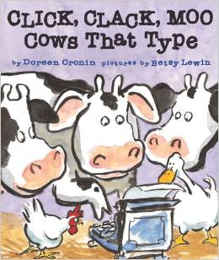

*Click, Clack, Moo Cows That Type* is a fictional picture book about the relationship between a farmer and his dairy cows. Farmer Brown has a problem when he hears typing sounds coming from inside his barn. The cows begin to leave him notes making specific requests, such as better working conditions and electric blanks to keep them warm at night.

*Farmer Brown has a problem. His cows like to type. All day long her hears. Click, clack, moo. Click, clack, moo. Clickety, clack, moo.*

This text includes three main examples of onomatopoeia, “*Click, clack, moo*.” The author uses these words to express the sounds of hooves typing on a typewriter as well as animal noises. When listening to or reading these words, the audience experiences the effect of connecting these sounds to the particular action of typing and the mooing of cows. Cornin uses these words as opposed to others in order to clearly describe the sounds, activate prior knowledge, and gain attention.

Cronin, D. (2000). *Click, clack, moo cows that type.* New York, NY: Simon & Schuster Books For Young Readers.

<https://www.youtube.com/watch?v=LMJq0xklqZc>

2. *Dinosaurumpus!*

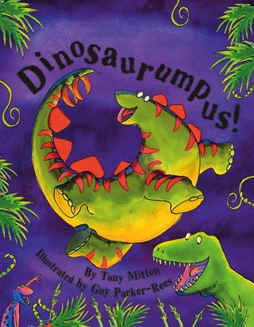

*Dinosaurumpus!* is a colorful picture book about different types of prehistoric dinosaurs. Within this rhyming story dinosaurs run, boom, shake, and shudder their way to the sludgy old swamp for the dinosaur romp. The audience will want to dance along while learning about their favorite dinosaurs.

*Donk! Donk! Donk! Here’s Triceratops jumping up and down doing dinosaur hops. He wears three horns on his big, bony head, and thunders along with a Bomp! Bomp! tread, Shake, shake, shudder… near the sludgy old swamp. The dinosaurs are coming. Get ready to romp.*

This text includes many examples of onomatopoeia. The author uses these words to express the sounds that the dinosaurs make when they move and dance. There is a different sound for each type of dinosaur. When listening to or reading the words, the audience will be able to visualize the movements of the humongous dinosaurs. Mitton uses these words as opposed to others in order to clearly describe the sounds, establish a rhythmic pattern, and gain attention.

Mitton, T. (2002). *Dinosaurumpus!.* London, UK: Orchard Books.

<https://www.youtube.com/watch?v=7JbYEZK9YHw>

3. *Wet Dog!*

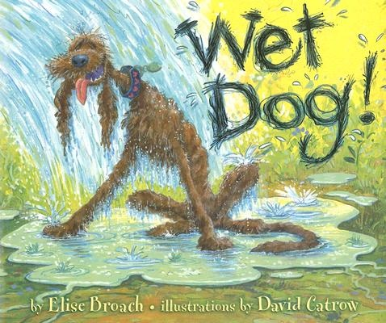

*Wet Dog!* is a fictional picture book about a good old, hot old dog, who tries to find ways to cool off. Meanwhile, the entire town is getting ready for a county wedding. He searches for water until he finds a chauffeur washing his car, a baker scrubbing baking pans, and a florist spraying a bouquet. This wet dog my not mix in well with the fancy wedding party.

*Old dog stepped in the soft, cool stream till the wet soaked through to him skin. Then he shook and he shook with a happy-dog smile, wagging his happy-dog tail… shaky-shake, shaky-shake, shake! “Wet dog!” cried the man with the shiny black car. “Shoo! Go on now, shoo!”*

This text includes several examples of onomatopoeia. The author uses these words to express the sounds made by both the dog and the humans throughout the story. When listening to or reading these words, the audience experiences the effect of connecting these sounds to the particular actions, such as a dog shaking or a person shooing something away. Broach uses these words as opposed to others in order to clearly describe the sounds, activate prior knowledge, insert humor, and gain attention.

Broach, E. (2005). *Wet dog!.* New York, NY: Dial Book For Young Readers.

<https://www.youtube.com/watch?v=IZhRiuj3Bho>

4. *The Seals on the Bus*

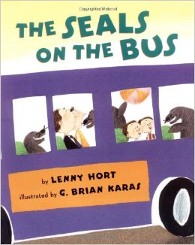

*The Seals on the Bus* is an animal filled picture book based off of the popular children’s song “The Wheels on the Bus”. This hilarious story is about two children and their parents who board a city bus to go to a party. After they take their seats, the next passengers to climb aboard are a group of seals. Every time the bus stops new kinds of animals climb aboard.

*The seals on the bus go errp, errp, errp, errp, errp, errp, errp, errp, errp. The seals on the bus go errp, errp, errp, all around the town.*

This text includes common examples of onomatopoeia. The author uses these words to express the sounds of animal noises. Many of these animal noises are common and easy to identify. When listening to or reading these words, the audience experiences the effect of connecting these sounds to the particular animal that makes them. Hort uses these words as opposed to others in order to clearly describe the sounds, activate prior knowledge, establish a musical rhythm, and gain attention.

Hort, L. (2003). *The seals on the bus.* New York, NY: Henry Holt and Company, LLC.

<https://www.youtube.com/watch?v=sPiF-R2bD4I>

5. *Piggie Pie!*

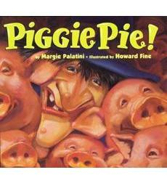

*Piggie Pie!* is a fictional picture book about a hungry witch named Gritch. She has a craving for piggy pie, but does not have eight plump piggies for her recipe. She decides to fly over the river and through the woods to Old MacDonald’s farm to get some pigs to make her delicious piggy pie. The pigs pretend to be different types of animals to hide from the witch.

*Gritch zoomed in for a thump-p-p! thump-p-p! eerrrrrch-ch landing!*

This text includes many examples of onomatopoeia. The author uses these words to express the sounds of animal noises and the actions of Gritch the witch. When listening to or reading these words, the audience experiences the effect of connecting these sounds to a particular action or a certain animal. Palatini uses these words as opposed to others in order to clearly describe the sounds, activate prior knowledge of animal noises, and gain attention.

Palatini, M. (1995). *Piggie pie!.* New York, NY: Clarion Books.

<https://www.youtube.com/watch?v=YTN0fTcW7MA>

6. *I Stink!*

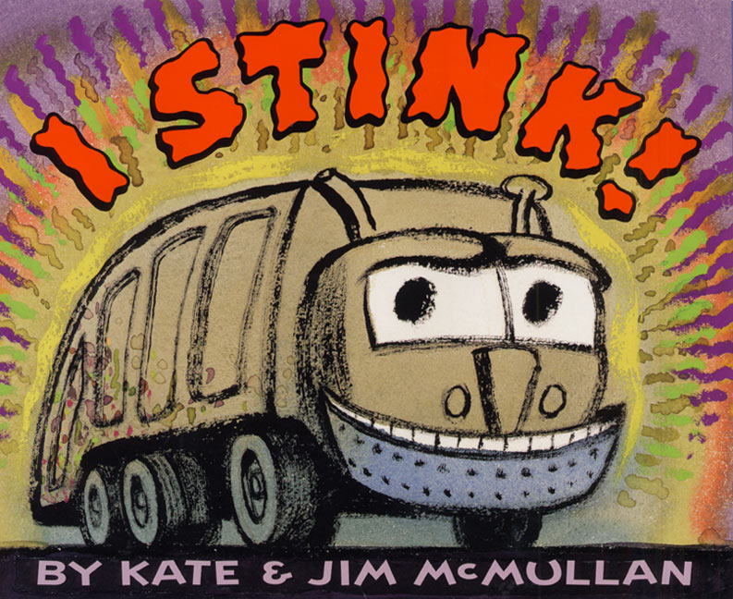

*I Stink!* is a fictional picture book about a garbage truck. As everyone else is sleeping, the garbage truck drives around eating trash. This garbage truck absolutely loves trash and all of its stinky smells.

*Hopper’s full. Hit the throttle. Gimme some gas. Rev me to the max. Engine? Roar!*

This text includes several examples of onomatopoeia. The author uses these words to express the sounds made by the garbage truck. When listening to or reading these words, the audience experiences the effect of making connections to certain sounds. The author uses these particular words to bring the garbage truck to life. McMullan uses these words as opposed to others in order to clearly describe the sounds, give the garbage truck the ability of expression, and gain attention.

McMullan, K. (2002). *I stink!.* New York, NY: HarperCollins Publishers.

<https://www.youtube.com/watch?v=zwG-QxJbuAQ>

7. *Mr. Brown Can Moo! Can You?*

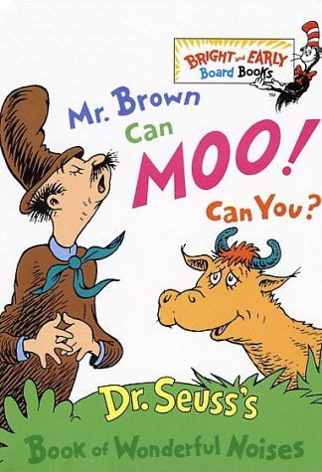

*Mr. Brown Can Moo! Can You?* is a noisy picture book filled with all kinds of sounds. This story is about the main character named Mr. Brown and all of the different sounds he can make. Mr. Brown can moo like a cow, buzz like a bee, pop like a cork, klopp like horses feet, cock a doodle doo like a rooster, can you?

*Oh, the wonderful sounds Mr. Brown can do! He can sound like a cow. He can go moo moo. He can sound like a bee. Mr. Brown can buzz. How about you? Can you go buzz buzz.*

This text includes many wonderful examples of onomatopoeia. The use of onomatopoeia is displayed on every page of the text. The author uses these words to express the sounds of animal noises and particular objects. Many of these sounds are common and easy to identify. When listening to or reading these words, the audience experiences the effect of connecting these sounds to the particular animal or object that makes them. Dr. Seuss uses these words as opposed to others in order to clearly describe the sounds, activate prior knowledge, interact with the audience through the use of questions, and gain attention.

Seuss, Dr. (1970). *Mr. Brown can moo! Can you?.* New York, NY: Random House, Inc.

<https://www.youtube.com/watch?v=_x5VMDG8QG0>

8. *Froggy Goes to Hawaii*

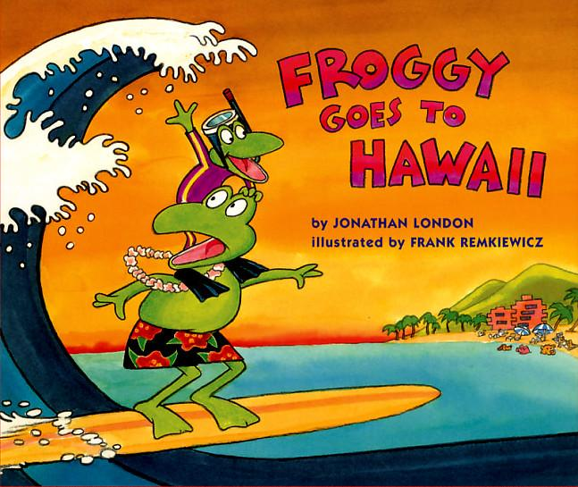

*Froggy Goes to Hawaii* is a fictional picture book about Froggy’s adventure to Hawaii with his family. Froggy goes surfing, swimming, and learns how to hula dance. However, his trip does not go quite as planned. This little frog seems to bring trouble along with him everywhere he goes.

*”It’s time to pack!” yelled his dad. So Froggy hopped out of bed and packed his toy plane- “zoom!” His toy boat- “vroom!” And his ukulele- “plink!”*

This text includes several examples of onomatopoeia. The author uses these words to express the sounds that the characters make as well as certain objects within the story. Some of these sounds are more common than others. When listening to or reading these words, the audience experiences the effect of connecting these sounds to the particular characters or objects. There are many sounds made by different characters that Froggy encounters throughout his adventures in Hawaii. London uses these words as opposed to others in order to clearly describe the sounds, activate prior knowledge, insert humor, and gain attention.

London, J. (2011). *Froggy goes to hawaii.* New York, NY: Puffin Books.

<https://www.youtube.com/watch?v=4hH2PqEsBS4>

9. *Muncha! Muncha! Muncha!*

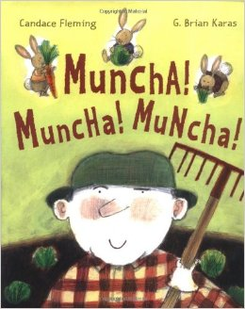

*Muncha! Muncha! Muncha!* is a fictional picture book filled with all sorts of clever sound effects. This story is about Mr. McGreely, his garden, and three hungry bunnies. Mr. McGreely tries his best to keep the three hungry bunnies out of his garden, so that they could not eat his delicious veggies.

*Lettuce! Carrots! Peas! Tomatoes! “Yum! Yum! Yummy!” said Mr. McGreely. “I’ll soon fill my tummy with crisp, fresh veggies.” But one night, when the sun went down and the moon came up, three hungry bunnies appeared. Tippy-Tippy-Tippy, Pat! Mucha! Muncha! Muncha!*

This text includes many examples of onomatopoeia. The author uses these words to express the sounds made by the three bunnies and Mr. McGreely. When listening to or reading these words, the audience experiences the effect of connecting these sounds to either the three bunnies or Mr. McGreely. “*Tippy-Tippy-Tippy, Pat!*” are the sounds consistently made by the three bunnies. Fleming uses these words as opposed to others in order to clearly describe the sounds, activate prior knowledge, represent particular characters, establish repetition, and gain attention.

Fleming, C. (2002). *Muncha! Muncha! Muncha!.* New York, NY: Atheneum Books For Young Readers.

<https://www.youtube.com/watch?v=uYoBYQqiP-8>

10. *Raindrop, Plop!*

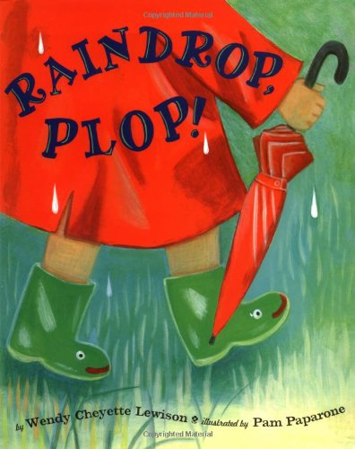

*Raindrop, Plop!* is a rhyming and counting picture book about different ways you can have fun on a rainy day. There are many unexpected things that you can do in rainy weather. You can explore outside with a coat, hat, umbrella, and boots. When the rain becomes too heavy, it is time to begin having fun inside until the sun comes out. It all starts with one little raindrop.

*One little raindrop, dark, dark sky. Two little raindrops, clouds go by. Three little raindrops, splat! splat! splat!*

This text includes several examples of onomatopoeia in groups of three, for example, “*splat! splat! splat!*” or “*tweet! tweet! tweet!”* The author uses these words to express the sound of raindrops or the common noise that birds make. When listening to or reading these words, the audience experiences the effect of connecting these sounds to sounds they may have heard before. Lewison uses these words as opposed to others in order to clearly describe the sounds, activate prior knowledge, establish a rhythmic pattern, and gain attention.

Lewison, W.C. (2004). *Raindrop, plop!.* New York, NY: Viking Books For Young Readers.

<https://www.youtube.com/watch?v=wUUGI8p_NzU>