**Literacy Plan**

Jennifer Eubank and Mary Lacen Kinkel

READ 680

Longwood University

**Section I: Literacy Need**

Cumberland County is a rural community in southern Virginia that was founded in 1749. The town consists of: three public schools at the elementary (pk-4), middle (5-8), and high school (9-12) levels; three small restaurants; and one State Park. According to the United States Census Bureau estimates of 2013, the community population of Cumberland is 9,841 people and made up of 64.6% Caucasian and 32.3% African-American. The Census Bureau reports that 16.3% of these individuals live below the poverty line. In addition, the Virginia Employment Commission estimates that 6.3% of the population of Cumberland in 2013 was unemployed, which was higher than the estimated 5.5% of Virginia. This puts the three schools in the 60th percentile for free and reduced lunch services and regulation lunches are provided for a high population of their students. In addition, the schools and the community have limited access to internet services due to one internet unit available to the entire county.

For this Literacy Plan, we collected data from two kindergarten classrooms at the elementary school level. Cumberland County Elementary School has approximately 723 students enrolled in Pre-K through 4th grade. The county faces internet access challenges, but the school had a revamping period where each classroom received a Promethean Board and the access to computer labs and laptop carts increased in 2008. In addition to the technology additions to the school, there is also a well-organized, leveled book room where teachers can access a wealth of resources and materials. According to the state, the school’s Report Card Rating lists as “Accredited with Warning” and they did not meet the accreditation benchmark requirements in the areas of math and English. The school is currently listed as Title I Focus for Federal Accountability.

In analyzing the 2012 PALs Benchmark data for the spring, it was determined that the area of need for the two kindergarten classrooms was Concept of Word. In total, Teacher B had nine students, out of twenty-three, who scored below the PALs Spring Benchmark score of 81. Teacher C had six students, out of twenty-two, below the acceptable Benchmark level. The students below the Benchmark level, as well as the students above, in both classes, demonstrated a high-need in the Pointing, Word Identification, and COW Word List tasks within the Concept of Word Assessment. According to PALs, the Benchmark score for Pointing is 5 and the Word Identification score and the COW Word List are 10. Teacher B reported the following number of students who scored below these benchmarks: 16 students in Pointing; 12 in Word Identification; and 13 in COW Word List. Teacher C reported the following number of students who scored below these benchmarks: 15 students in Pointing; 16 in Word Identification; and 14 in COW Word List. Therefore, in both kindergarten classes, over 50% of students are struggling with Concept of Word tasks.

**Section II: Possible Solutions**

*Possible Solution 1: Fundations*

One possible solution to meet the Concept of Word need is the Fundations program published by Wilson Language Basics for K-3. This program is used as a prevention and early-intervention tool to help reduce reading and spelling failures through the use of interactive language activities. According to the What Works Clearinghouse Program Report Summary, the Fundations program, “is aimed at students in grades K–3 and involves daily 30-minute lessons which focus on carefully-sequenced skills that include print knowledge, alphabet awareness, phonological awareness, phonemic awareness, decoding, spelling, and vocabulary development” (2010). Fundations can also be adapted to be used with small-groups for 40-60 minutes a day. The program was created to be used in addition to existing reading programs within general education classrooms and not to replace what teachers are already using.

This solution would address the literacy need of the kindergarten students because it includes activities that target Concept of Word abilities such as tracking print left-to-right and top-to-bottom. Fundations ensures to address the fundamentals skills that kindergartners need to be successful (Wilson Fundations, 2011). To implement the program, Fundations requires the purchase a classroom set which includes one teacher’s kit and materials for 25 students. One example component within the student kit is the baby owl finger puppet. The students can use these puppets in motivating and interactive Concept of Word lessons and pointing activities.

Although the program would address the specified need of these kindergarten students, there are a few pitfalls to consider as well. First, the program costs a total of $1,279 per classroom set. Each teacher would receive an abundant amount of materials, however, this program may be out of the price range for this school system. Second, Fundations requires teachers to participate in a training program before they are certified to use the classroom sets. This Professional Development would consist of a total of four days with a Coach and would need to be incorporated into the school schedule. Lastly, the lessons require 30 minutes of instructional time to be included in the teacher’s daily schedule.

*Possible Solution 2: Wonders*

The second possible solution to meet the Concept of Word need is the Wonders program published by McGraw-Hill. The program for kindergarten includes a variety of components such as: reading/writing workshop, 32 literature big books, leveled readers, teacher’s edition guide, practice book, interactive read-aloud cards, work station activity cards, retelling cards, visual vocabulary cards, 42 teaching posters, word work resources, and assessments. In addition, the program offers lessons that allow for scaffolding and differentiation to support a wide-range of students. There are also ready-made presentations that include interactive mini-lessons and sequenced resources that are compatible with technology to make learning come to life.

This solution would address the literacy need of the kindergarten students because it provides a multitude of resources that would be beneficial in supporting Concept of Word development. For example, Wonders provides a set of big books with accompanying little books for individual use. These big books could be used to model Concept of Print and Concept of Word tasks and the opportunity to scaffold to guided, or independent, practice with the little books. In addition, the materials can be used to enhance word identification practice in context and in isolation.

There are a few pitfalls to consider before choosing this program. First, the *Reading Wonders Kindergarten System* with a six year subscription costs a total of $2,651.19. Each teacher would receive an assortment of teacher, student, and classroom materials; however, this program may be out of the price range for this school system. In addition, the McGraw-Hill publishers have noted that the prices are subject to change without notice. Second, Wonders would take the place of an existing reading program for kindergarten. Thus, the program would require an extensive commitment from the teachers and administration before it could be implemented in the kindergarten classrooms.

*Possible Solution 3: Community Coaching Cohort Model (CCCM)*

The third possible solution to meet the Concept of Word need is the Community Coaching Cohort Model (CCCM) designed by Dr. Sara Miller and Angela Stewart. The Community Coaching Cohort Model (CCCM) was designed with a focus on relationships, collaboration, research, and personal reflection in hopes of creating professional development as well as a learning community among teams of teachers (4-8). The CCCM consists of a nine-week cycle, three-phase cycle, where teams of teachers and a literacy coach analyze, reflect, and improve their literacy instruction. The first phase consists of the first three weeks that the coach works with the teams and covers: inquiry and data analysis; research to address the inquiry topics; and lesson development for demonstration lessons with the literacy coach in individual classrooms. The second phase consists of the next three weeks in the cycle and covers: modeling and debriefing; a mid-cycle reflection; and more research surrounding the inquiry topics. The third phase consists of the last three weeks of the model and consists of: lesson development; coaches’ modeling and debriefing; and a final reflection. The model allows teachers to work together and collaborate with one another, while also receiving team and individual coaching from a literacy coach to improve their literacy instruction.

This solution would address the literacy need of the kindergarten students because it allows the teacher to receive support and coaching in the specific area of Concept of Word development. The teachers can receive Professional Development from trained Reading Specialists and/or Literacy Coaches who are knowledgeable of materials, resources, and instructional practices that could benefit student Concept of Word growth. In addition, teachers would have the opportunity to experience demonstration Concept of Word lessons and debriefing sessions both individually with coaches and in professional development teams.

There are two possible pitfalls to consider with the Community Coaching Cohort Model. First, the model would require the necessary support and guidance from a knowledgeable reading specialists and/or literacy coach at the school. Without the support of this individual, or individuals, the model would not be possible. Second, the model requires the time and collaboration efforts of the classroom teachers. The nine-week cycle was designed to support classroom instruction; however, if teachers are not willing to put in the time or are not willing to receive assistance, then the model would not be successful.

**Section III. Solution**

*Description and Justification Statement*

The solution that would best address the school’s literacy need is a form of a Professional Learning Community (PLC). The Community Coaching Model (CCCM) designed by Dr. Sara Miller and Angela Stewart would be effective because it allows the kindergarten teachers to: collaborate in a learning community; analyze data as a team; research best practices for instruction; implement instructional practices in the classroom; receive opportunities for lesson observations with the literacy coach; receive lesson development support in a team and individual coaching environment; and evaluate and reflect on their teaching experiences. In addition, the CCCM addresses the literacy need of the students because it allows the teachers to receive support and coaching from the Literacy Coach in the specific area of need, Concept of Word.

Currently, Cumberland County Elementary kindergarten teachers meet weekly to develop lesson plans as a team. However, these meetings are not driven by data-analysis and research based instructional practices for Concept of Word development. Furthermore, the teachers do not have the opportunity to collaborate with a literacy coach and/or a reading specialist in their weekly meetings. The CCCM would serve as a PLC model for teachers to receive additional support from a literacy coach, which in return will foster productive, structured, and collaborative weekly meetings that are data-driven and incorporate research based practices. The CCCM will also hold teachers accountable through the implementation and evaluation process.

|  |  |
| --- | --- |
| *Methods* | * On-going and continuous support and feedback from grade-level colleagues and a literacy coach * Job-embedded in connection to personal and student goals * Collaboration in a team format * Reflective of previous and future instructional practices * Inquiry-based discussions driven by assessment data (summative and formative) |
| *Materials* | * COW word lists * COW poems on large chart paper OR big books * Interactive Charts * COW poem pictures * Pointers * Sentence strips * COW scoring forms * Optional: Promethean or SmartBoard * Graphic Organizers |
| *Techniques/Strategies* | Teachers will implement a variety of techniques and strategies to develop students’ word awareness and COW such as:   * Modeling finger-pointing of repetitive texts * Modeling how to identify specific words * Explicitly teach directionality of text and spaces of words within the text * Allow students to practice tracking repetitive text with pointers or fingers * Using a variety of COW activities (cutting and re-assembling sentences, rhyming word activities, clap words, ect.) * Incorporating a variety of types of reading (read-aloud, choral reading, echo reading, independent reading) |

*Implementation*

In the spring of 2015, the literacy plan will be presented to the school principal for approval before the implementation of CCCM. After approval, an overview of the CCCM will be introduced to the kindergarten team during the teacher work week in the fall for the 2015-2016 school year. Teachers will also be asked to complete a Google Doc form to provide their availability for team meetings. Implementation of the formal model will begin during the first week of school.

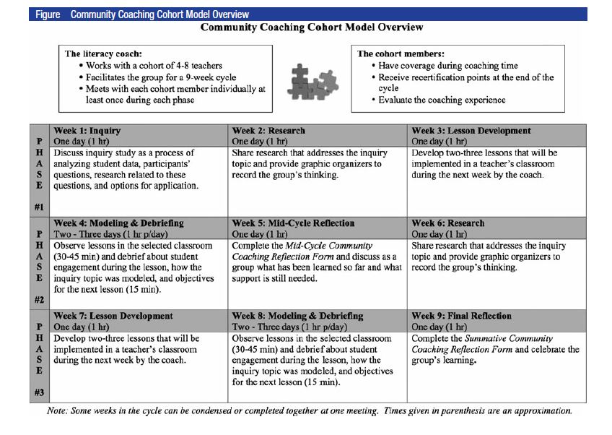Once the CCCM has begun the implementation process, the plan will continue for nine-weeks. During Week five, the teachers will complete the *Mid-Cycle Community Coaching Reflection Form.* As a team, the teachers will meet to discuss their reflections of what they have learned and request additional support that may be needed.At the end of the nine-weeks, the teachers will complete the *Summative Community Coaching Reflection Form* and the team will share their successes and student growth together. An overview of the implementation process designed by Miller and Steward is included below.

**IV. Professional Development Plan**

The professional development plan will be introduced to the kindergarten teachers during the teacher work week during a one-hour meeting. In the first thirty minutes the literacy coach will engage the teachers in an ice-breaker activity. For this activity, the literacy coach will ask teachers to draw a visual representation of who they are using symbols, colors, ect. (Protocol: Ice Breakers and Warm-Ups). The literacy coach will then share out the visuals created by teachers to connect with and understand the adult learners’ interests and past experiences. Then, the remaining thirty minutes will be focused on introducing the CCCM to the teachers. The literacy coach will distribute a CCCM chart to each of the kindergarten teachers. The literacy coach will be enthusiastic and positive when discussing each of the steps in the model, as well as gear the conversation to how each of the steps could benefit the teachers. There will be time at the end of the session for questions and concerns regarding CCCM and the implementation process. In addition, teachers will be asked to complete a Google Doc form to provide their availability for the weekly PLC meetings.

During the first week of school, the kindergarten teachers will participate in the first official PLC meeting following the CCCM model. This one-hour meeting will include the Inquiry topics within phase one of the model. The literacy coach will use the Data Driven Dialogue protocol format to lead the teachers in inquiry-based discussions of PALs Assessment data from the spring 2015. According to adult learning theories, adults are internally motivated and self-directed. Therefore, the literacy coach will lead the adult learners toward inquiry before jumping into analyzing data and providing facts. Phase one of the Data Driven Dialogue Tool allows teachers to make predictions of the spring data. Teachers will complete the phase one form independently. After this phase is complete, the teachers will share out their predictions with the team. Then, the literacy coach will distribute spring PALs data from each of the kindergarten classrooms. Using this data, teachers will individually participate in phase two of the Data Driven Dialogue Tool which allows them to make observations about the data. After this phase is complete, the teachers will share out their observations with the team. Lastly, the teachers will individually make inferences about the observations they made from the data in phase two. After this phase is complete, the teachers will share out their inferences with the team. The literacy coach’s role throughout this meeting is to facilitate the adult learners’ meaningful discussions and findings of the Concept of Word area of need for kindergarten 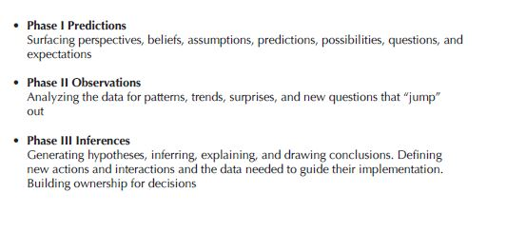students. The details regarding each phase of the Data Driven Dialogue Tool are included below.

During the second week of school, the kindergarten teachers will participate in their second PLC meeting following the CCCM model. This one-hour meeting will include the Research topics within phase one of the model. This research meeting will be guided by the inquiry topics from the first PLC meeting. At the beginning of the session, the literacy coach will distribute notecards to each of the teachers with quotes from the article *Developing Concept of Word: The Work of Emergent Readers* by Susan Gately. The teachers will take time to silently reflect about the meaning of the quote and how it relates to their work (Protocol: Block Party). Then, teachers share out their quotes and how they connect with their COW instructional experiences with the team. According to adult learning theories, adults bring life experiences and knowledge to learning experiences. Therefore, the literacy coach will lead the adult learners in reflective learning opportunities.

The literacy coach will use the pre-reading activity to transition into examining COW instructional strategies within the research. A packet of research materials will be distributed to each of the teachers that includes: *Developing Concept of Word: The Work of Emergent Readers* article; pages 138-139 in *Creating Literacy Instruction for All Students* by Thomas G. Gunning; and pages 115-119 in *Words Their Way (5th Edition)* by Donald Bear, Marcia Invernizzi, Shane Templeton, and Francine Johnston. Teachers will collaborate with a partner to record information and reactions to the COW research in a graphic organizer. To end the PLC meeting, the literacy coach will facilitate a whole-team discussion about how the research is helpful to the kindergarten teachers’ practice and how the COW strategies can be implemented within their own classrooms.

The literacy coach will provide short-term support for teachers by assisting them in creating COW lesson plans that incorporate research-based instructional practices and strategies. In addition, the literacy coach can assist teachers in the team with selecting materials and resources that support effective COW instruction. The literacy coach will be available to observe COW lessons and debrief with individual teachers in the kindergarten team. Long-term support will be provided by revisiting research topics, discussing student growth and teacher reflections, and continuing to assist with developing COW lesson plans.

**V. Timeline for Implementation**

|  |  |
| --- | --- |
| *Date* | *Assessment/Monitor Plan* |
| **Monday, August 31st, 2015** | -Introduction of the CCCM during Teacher Work Week |
| **Friday, September 4th, 2015** | -Teachers submit Google Doc Availability Form |
| **Week of Sept. 8th-Sept. 11th**  (One hour meeting) | **-Phase #1 of CCCM begins**  -First PLC Inquiry meeting is held with the kindergarten team (based on teacher availability) |
| **Week of Sept. 14th-Sept. 18th**  (One hour meeting) | -Second PLC Research meeting is held with the kindergarten team (based on teacher availability) |
| **Week of Sept. 21st-Sept. 25th**  (One hour meeting) | -Third PLC Lesson Development meeting is held with the kindergarten team (based on teacher availability) **-Phase #1 of CCCM ends** |
| **Week of Sept. 28th-Oct. 2nd**  (2-3 days, one hour per day) | **-Phase #2 of CCCM begins** -Literacy Coach observes individual kindergarten teacher lessons & holds debriefing meetings with teachers |
| **Week of Oct. 5th-Oct. 9th**  (One hour meeting) | **\*Monitor the Implementation and Success of the Plan**  -Fourth PLC meeting is held with the kindergarten team (based on teacher availability) to complete the *Mid-Cycle Community Coaching Reflection Form* |
| **Week of Oct. 12th-16th**  (One hour meeting) | **\*Monitor the Implementation and Success of the Plan** -Fifth PLC meeting is held with the kindergarten team (based on teacher availability) to analyze Fall PALs Assessment data and review research **-Phase #2 of CCCM ends** |
| **Week of Oct. 19th-23rd**  (One hour meeting) | **-Phase #3 of CCCM begins** -Sixth PLC Lesson Development meeting is held with the kindergarten team (based on teacher availability) |
| **Week of Oct. 26th-Oct. 30th**(2-3 days, one hour per day) | -Literacy Coach observes individual kindergarten teacher lessons & holds debriefing meetings with teachers |
| **Week of Nov. 2nd-Nov. 6th**  (One hour meeting) | **\*Monitor the Implementation and Success of the Plan**  -Seventh PLC meeting is held with the kindergarten team (based on teacher availability) to complete the *Summative Community Coaching Form* and Team Celebration **-Phase #3 of CCCM ends** |

**\****Hypothetical problems that could affect implementation of the literacy plan may include: testing schedules, weather, and conflicting teacher schedules. As the issues arise, the schedule would be adjusted accordingly by combining weeks within the model.*

**References**

Bear, D., Invernizzi, M., Templeton, S., & Johnston, F. (2012). *Words their way: Word study for phonics, vocabulary and spelling instruction (5th ed.).* New York, NY: Pearson Education, Inc.

Gately, S. (2004). Developing concept of word: The work of emergent readers. *Teaching Exceptional Children,* 36(6), 16-22.

Gunning, T.G. (2010). *Creating literacy instruction for all students (7th ed.).* Boston, MA: Allyn and Bacon.

Miller, S., Stewart, A. (2014). Literacy learning through team coaching. *The Reading Teacher*, 67(4), 290-298.

NSRF Protocols and Activities from A to Z. (2014). Retrieved fromhttp://www.nsrfharmony.org/free-resources/protocols/a-z

Reading Wonders. (n.d.). Retrieved from [http://mhreadingwonders.com/grade/#kindergarten/tab/components/components/all/display/carousel](http://mhreadingwonders.com/grade/" \l "kindergarten/tab/components/components/all/display/carousel" \t "_blank)

United States Census Bureau. (2015). *State and county quickfacts for cumberland, virginia* [Data File]. Retrieved from http://quickfacts.census.gov/qfd/states/51/51049.html

Virginia Employment Commission. (2015). *Virginia community profile for cumberland, virginia* [Data File]. Retrieved from www.virginiaLMI.com

What Works Clearinghouse. (2010). *Fundations Report Summary*. Retrieved from http://ies.ed.gov/ncee/wwc/interventionreport.aspx?sid=196